**REF_SCH TOP LEVEL**

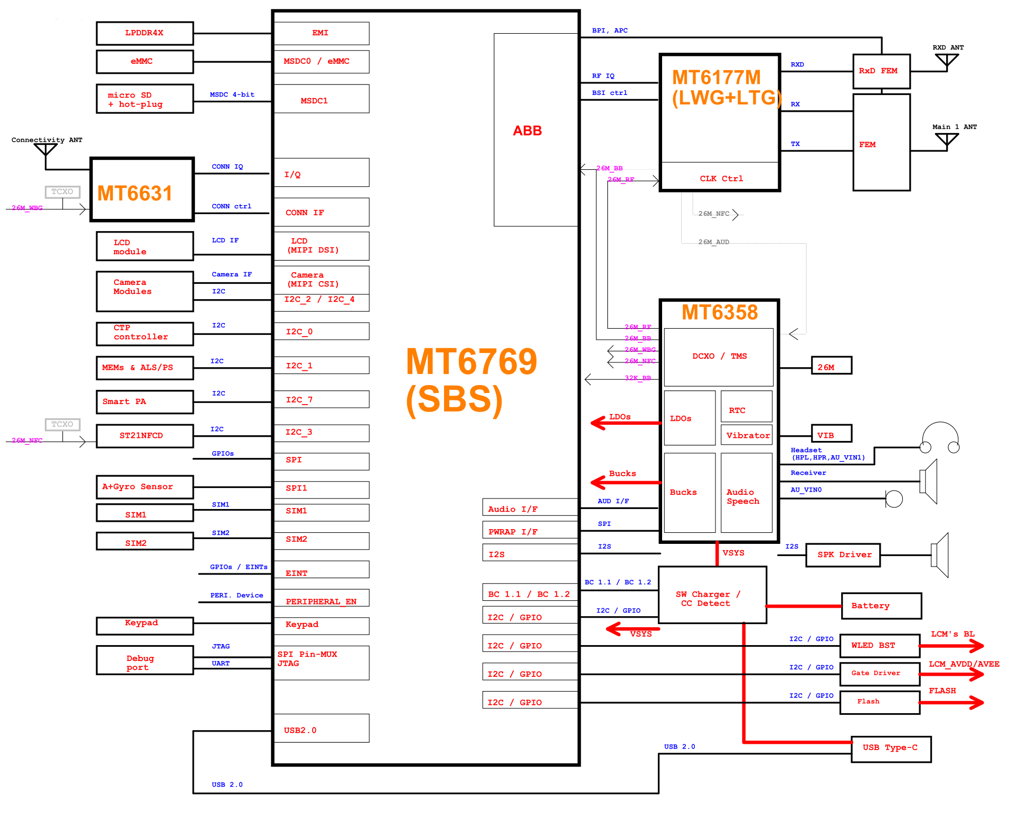

**02_I2C_ID_Overview**

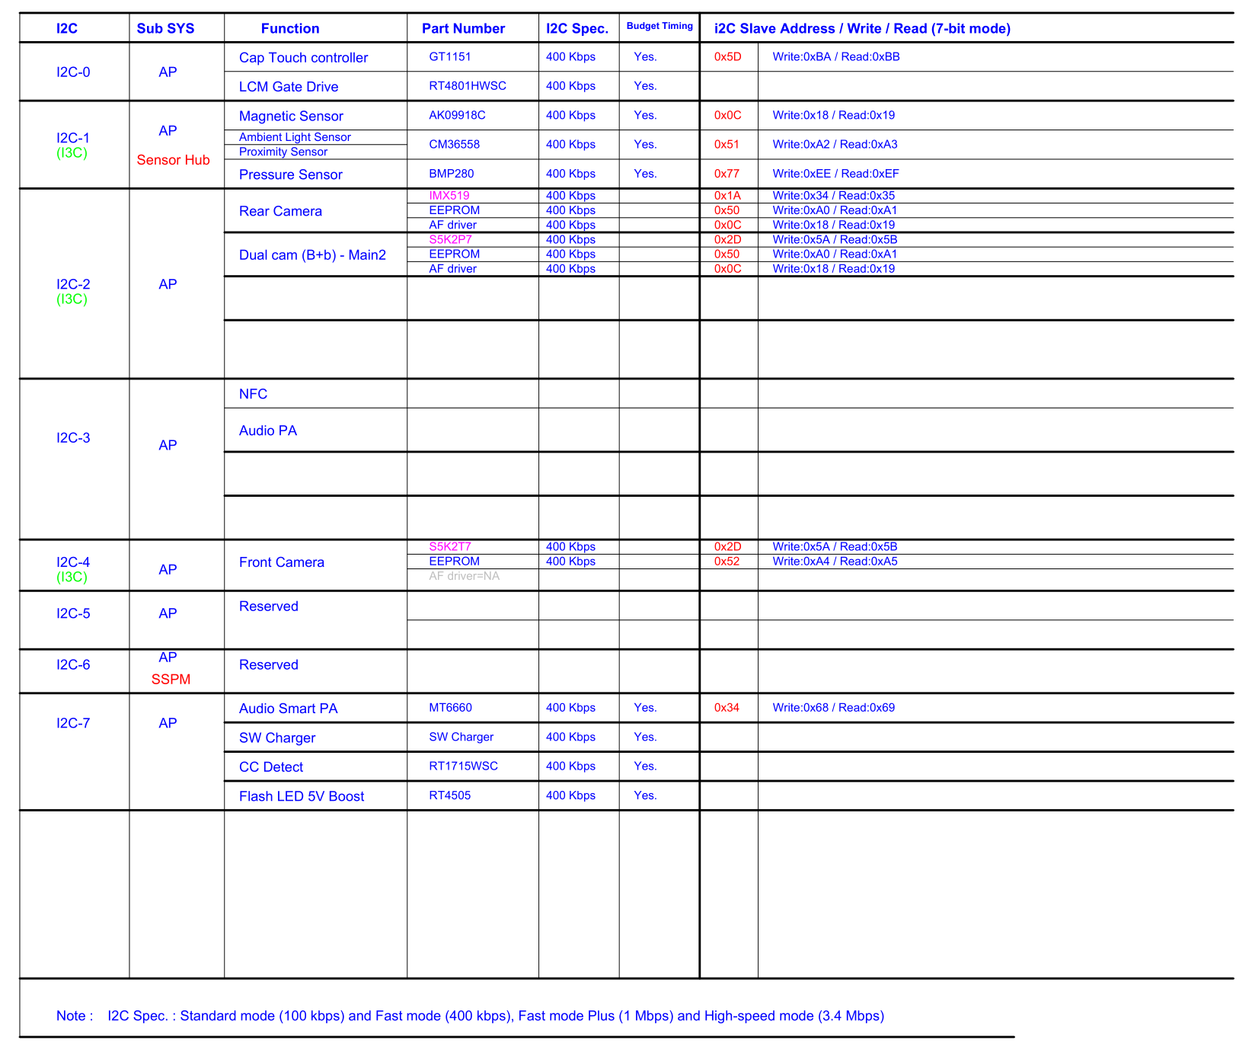

**10_BB_POWER_PDN**

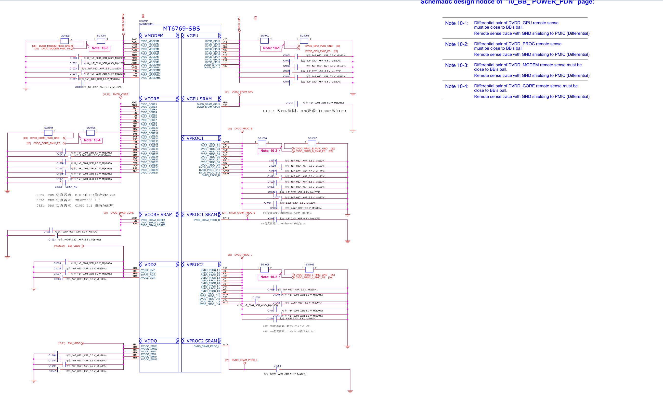

**11_BB_POWER_IO**

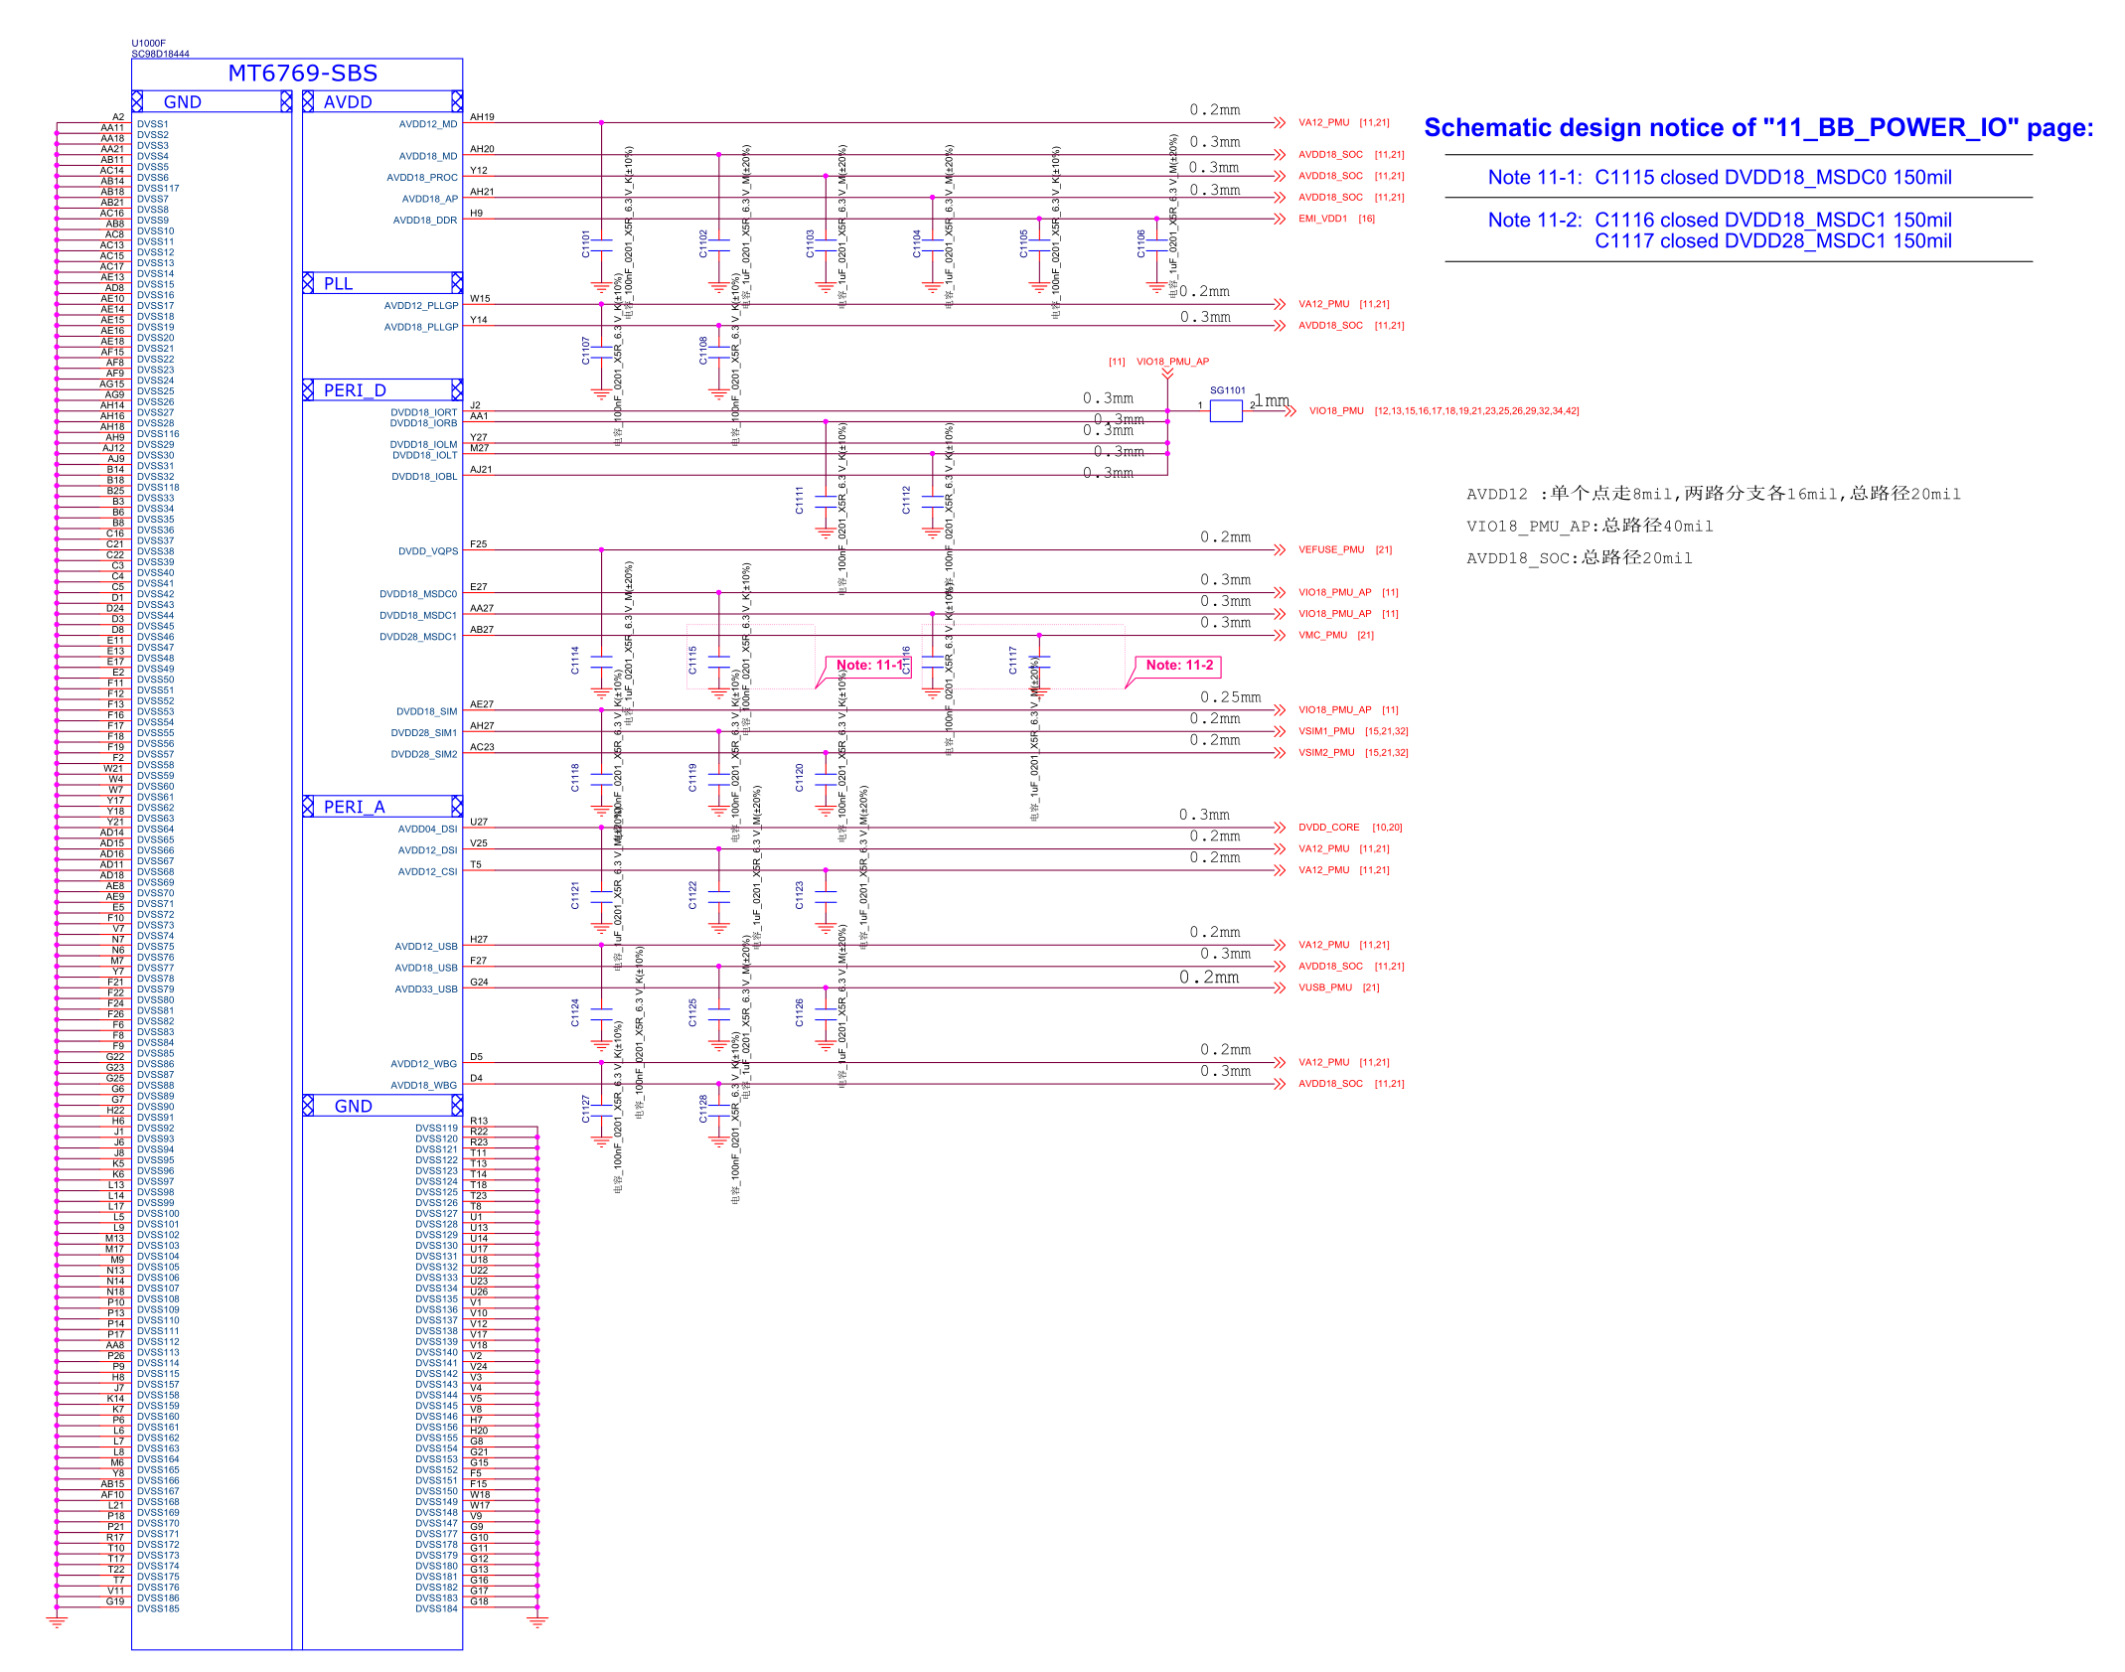

**12_BB_1**

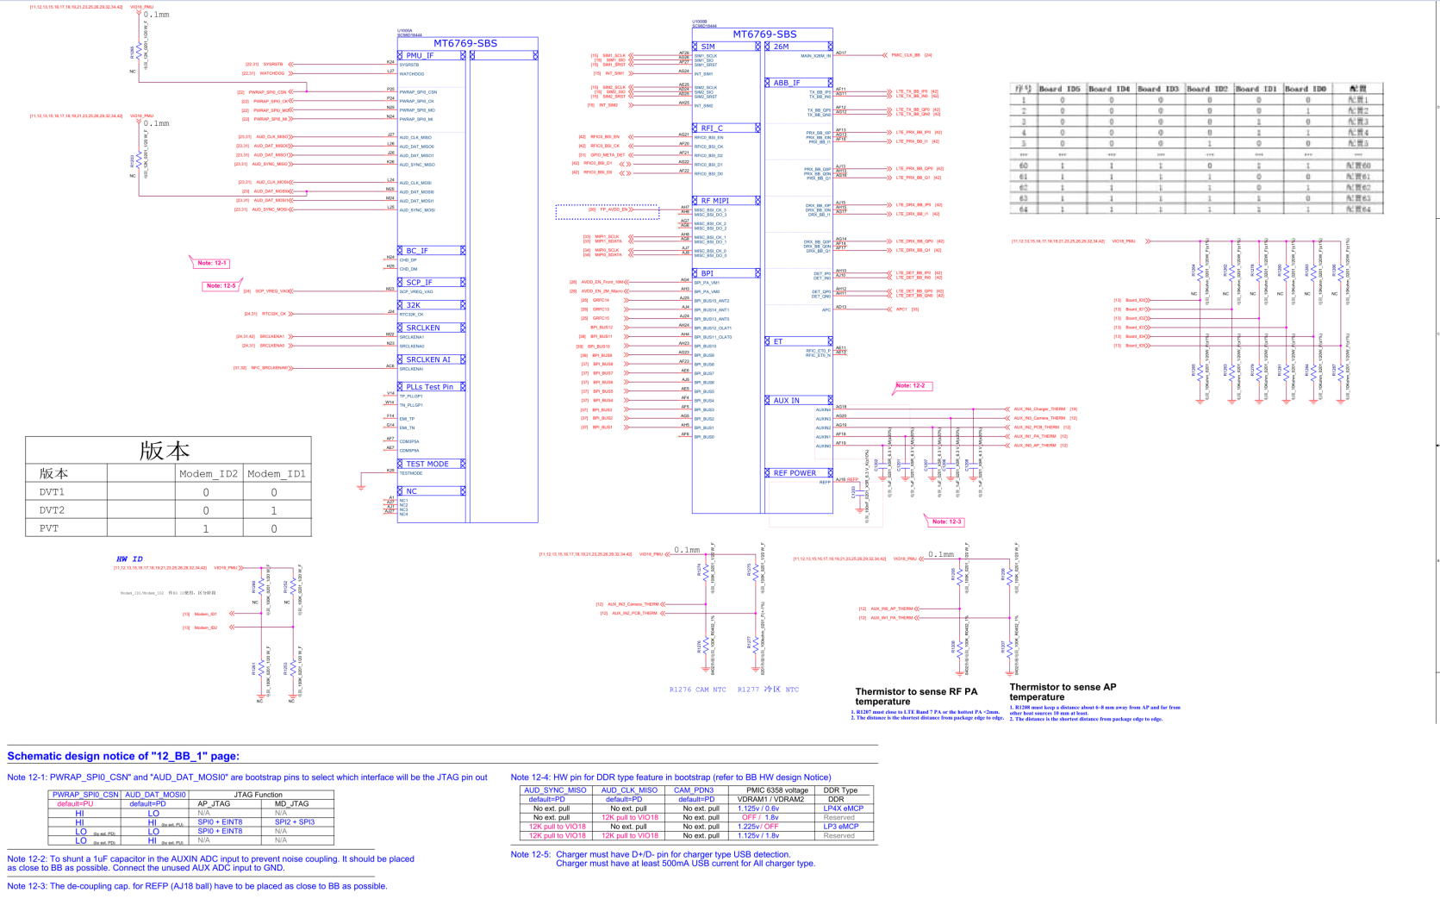

**13_BB_2**

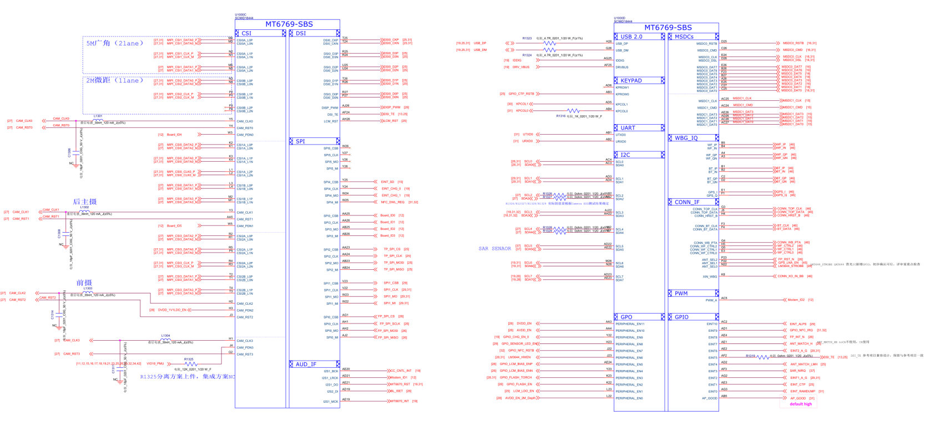

**14_BB_3**

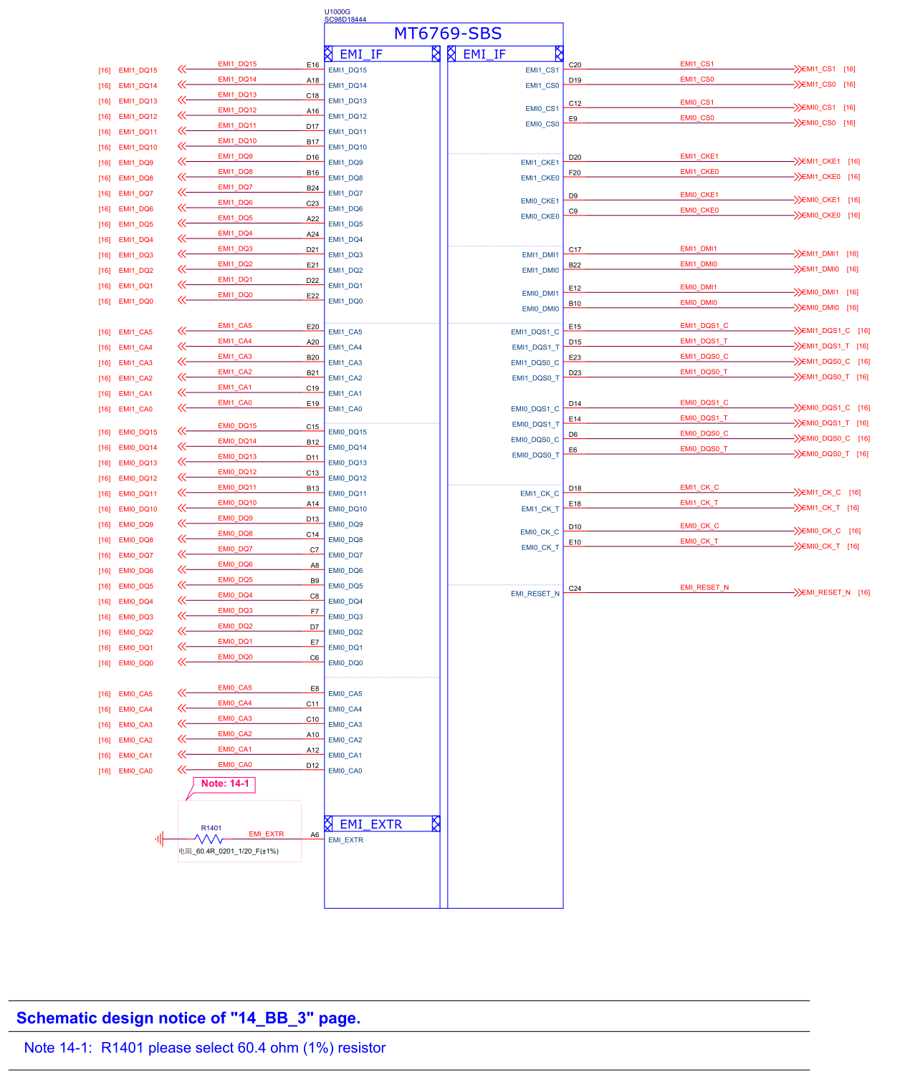

**15_MEMORY_SD SIM_CARD**

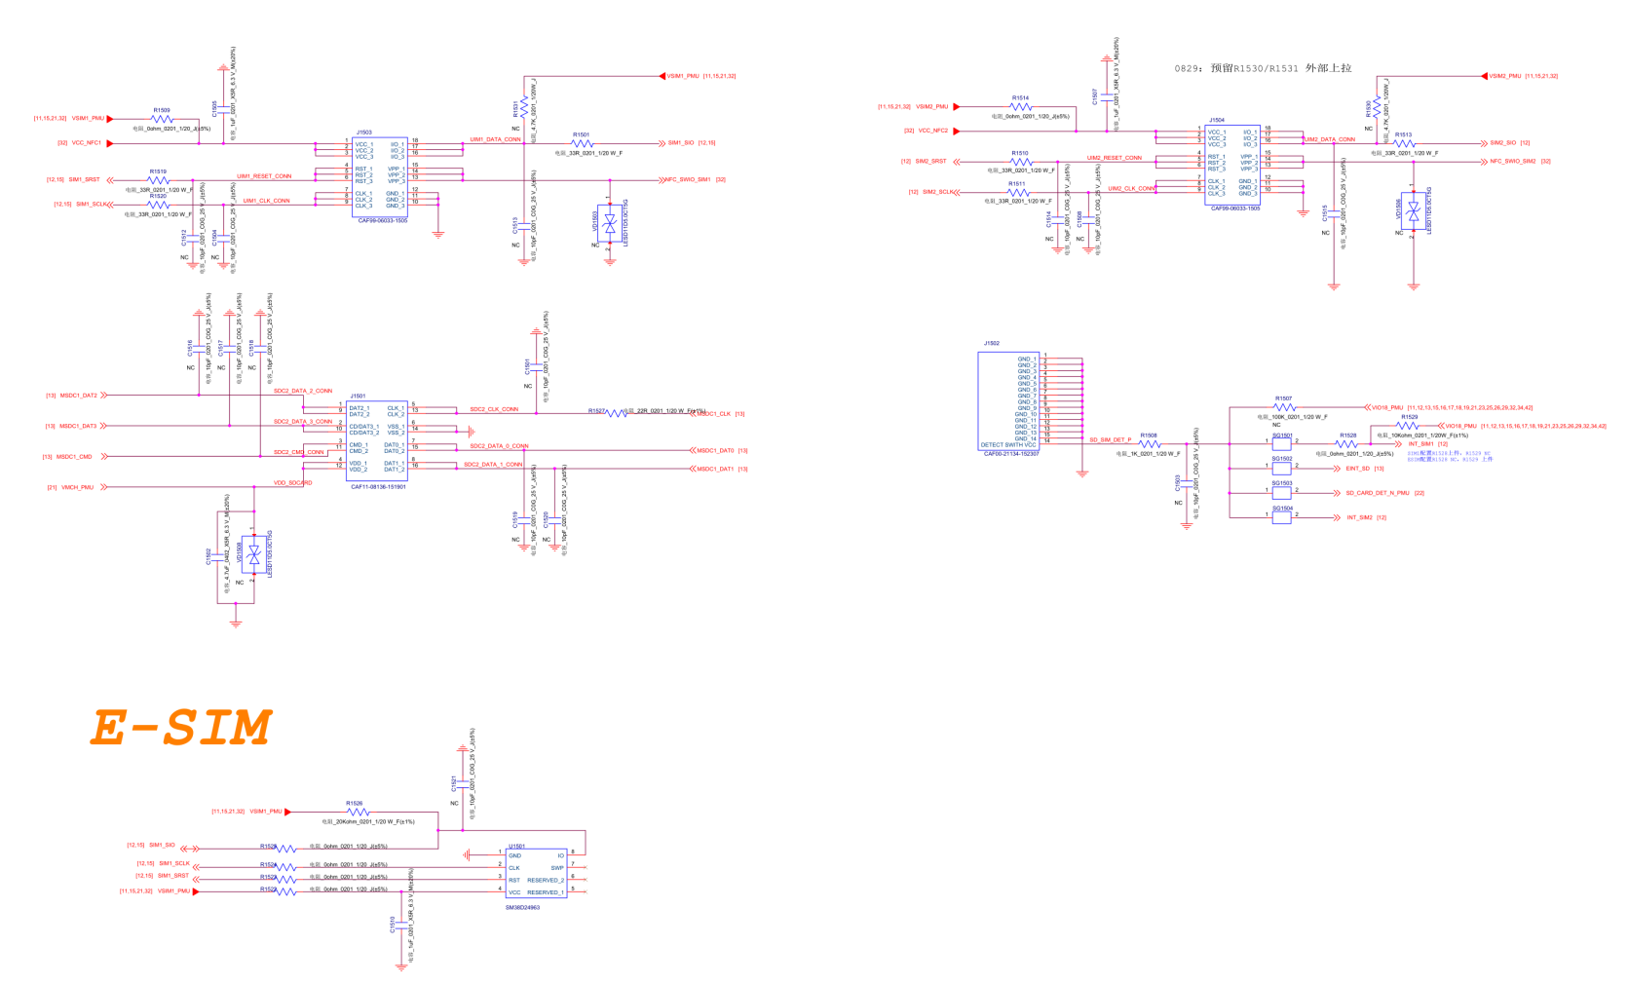

**16_Memory_EMMC_LPDDR4X**

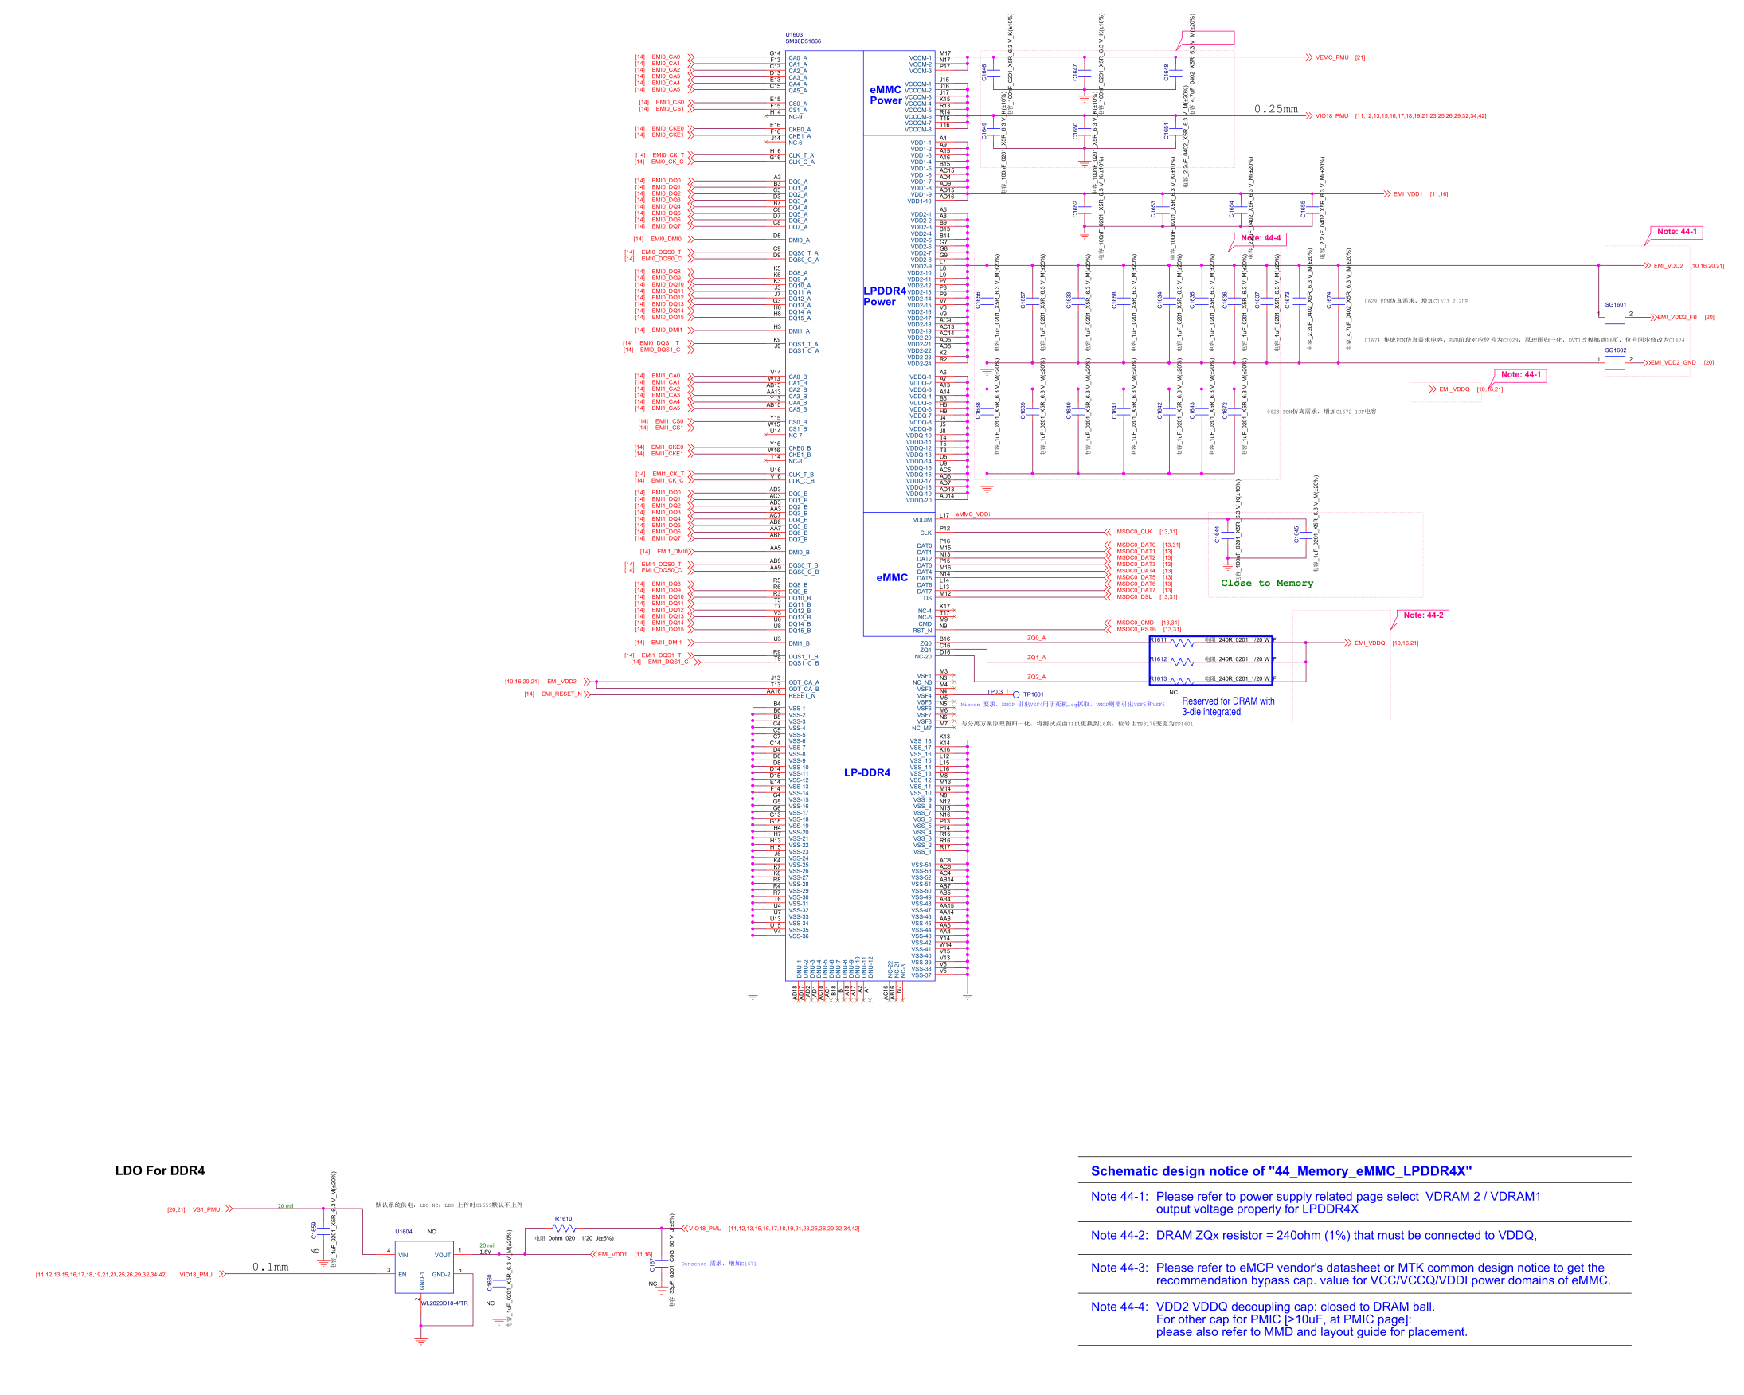

**17_AUDIO_Earphone_MIC**

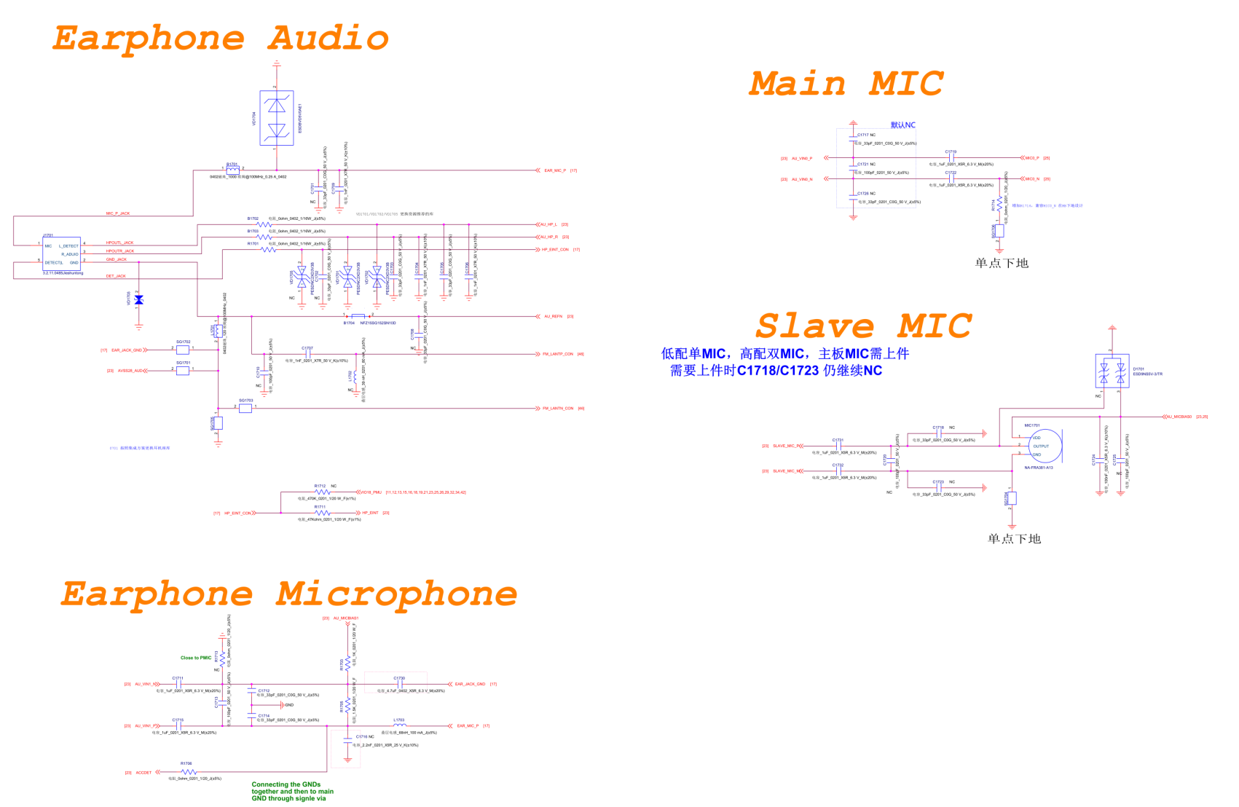

**18_AUDIO_Speaker_Receiver**

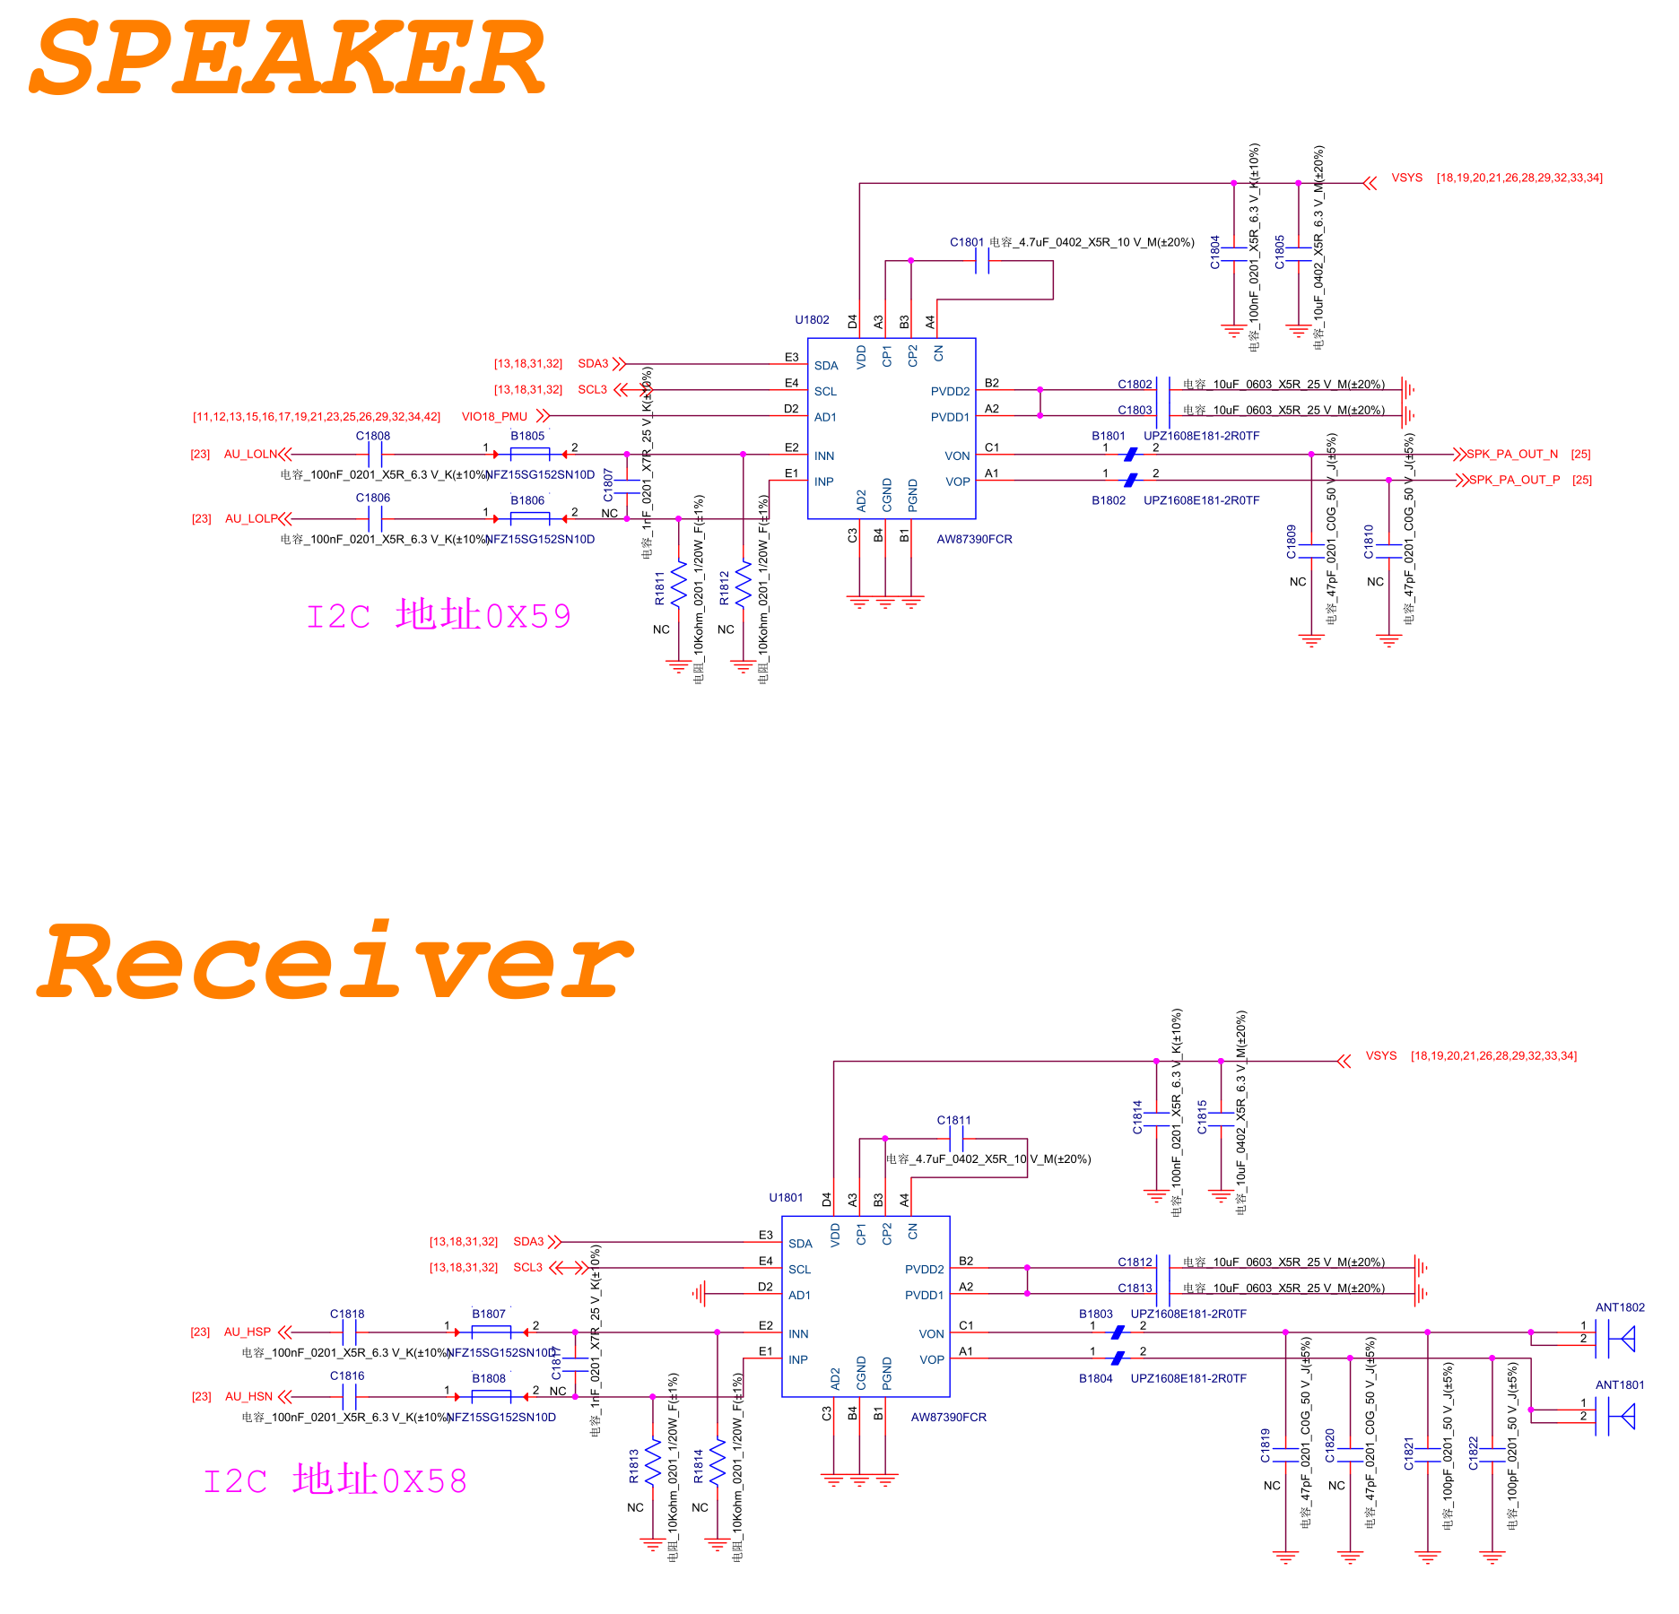

**19_Charger**

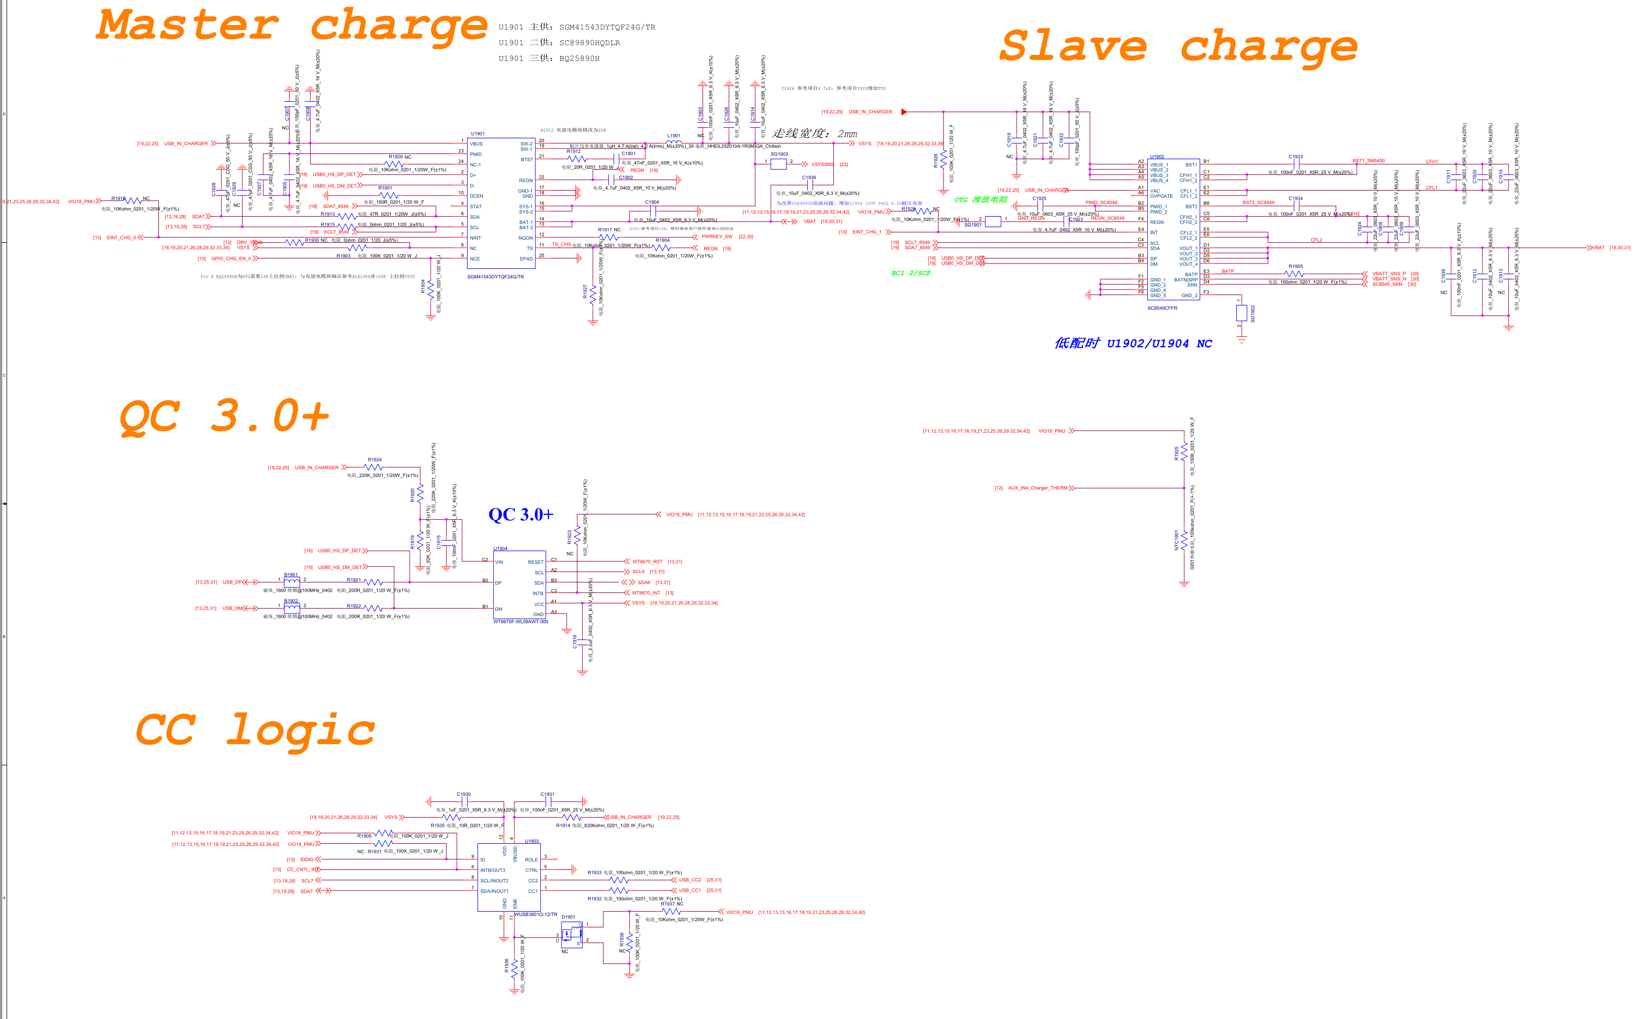

**20_POWER_MT6358_Buck**

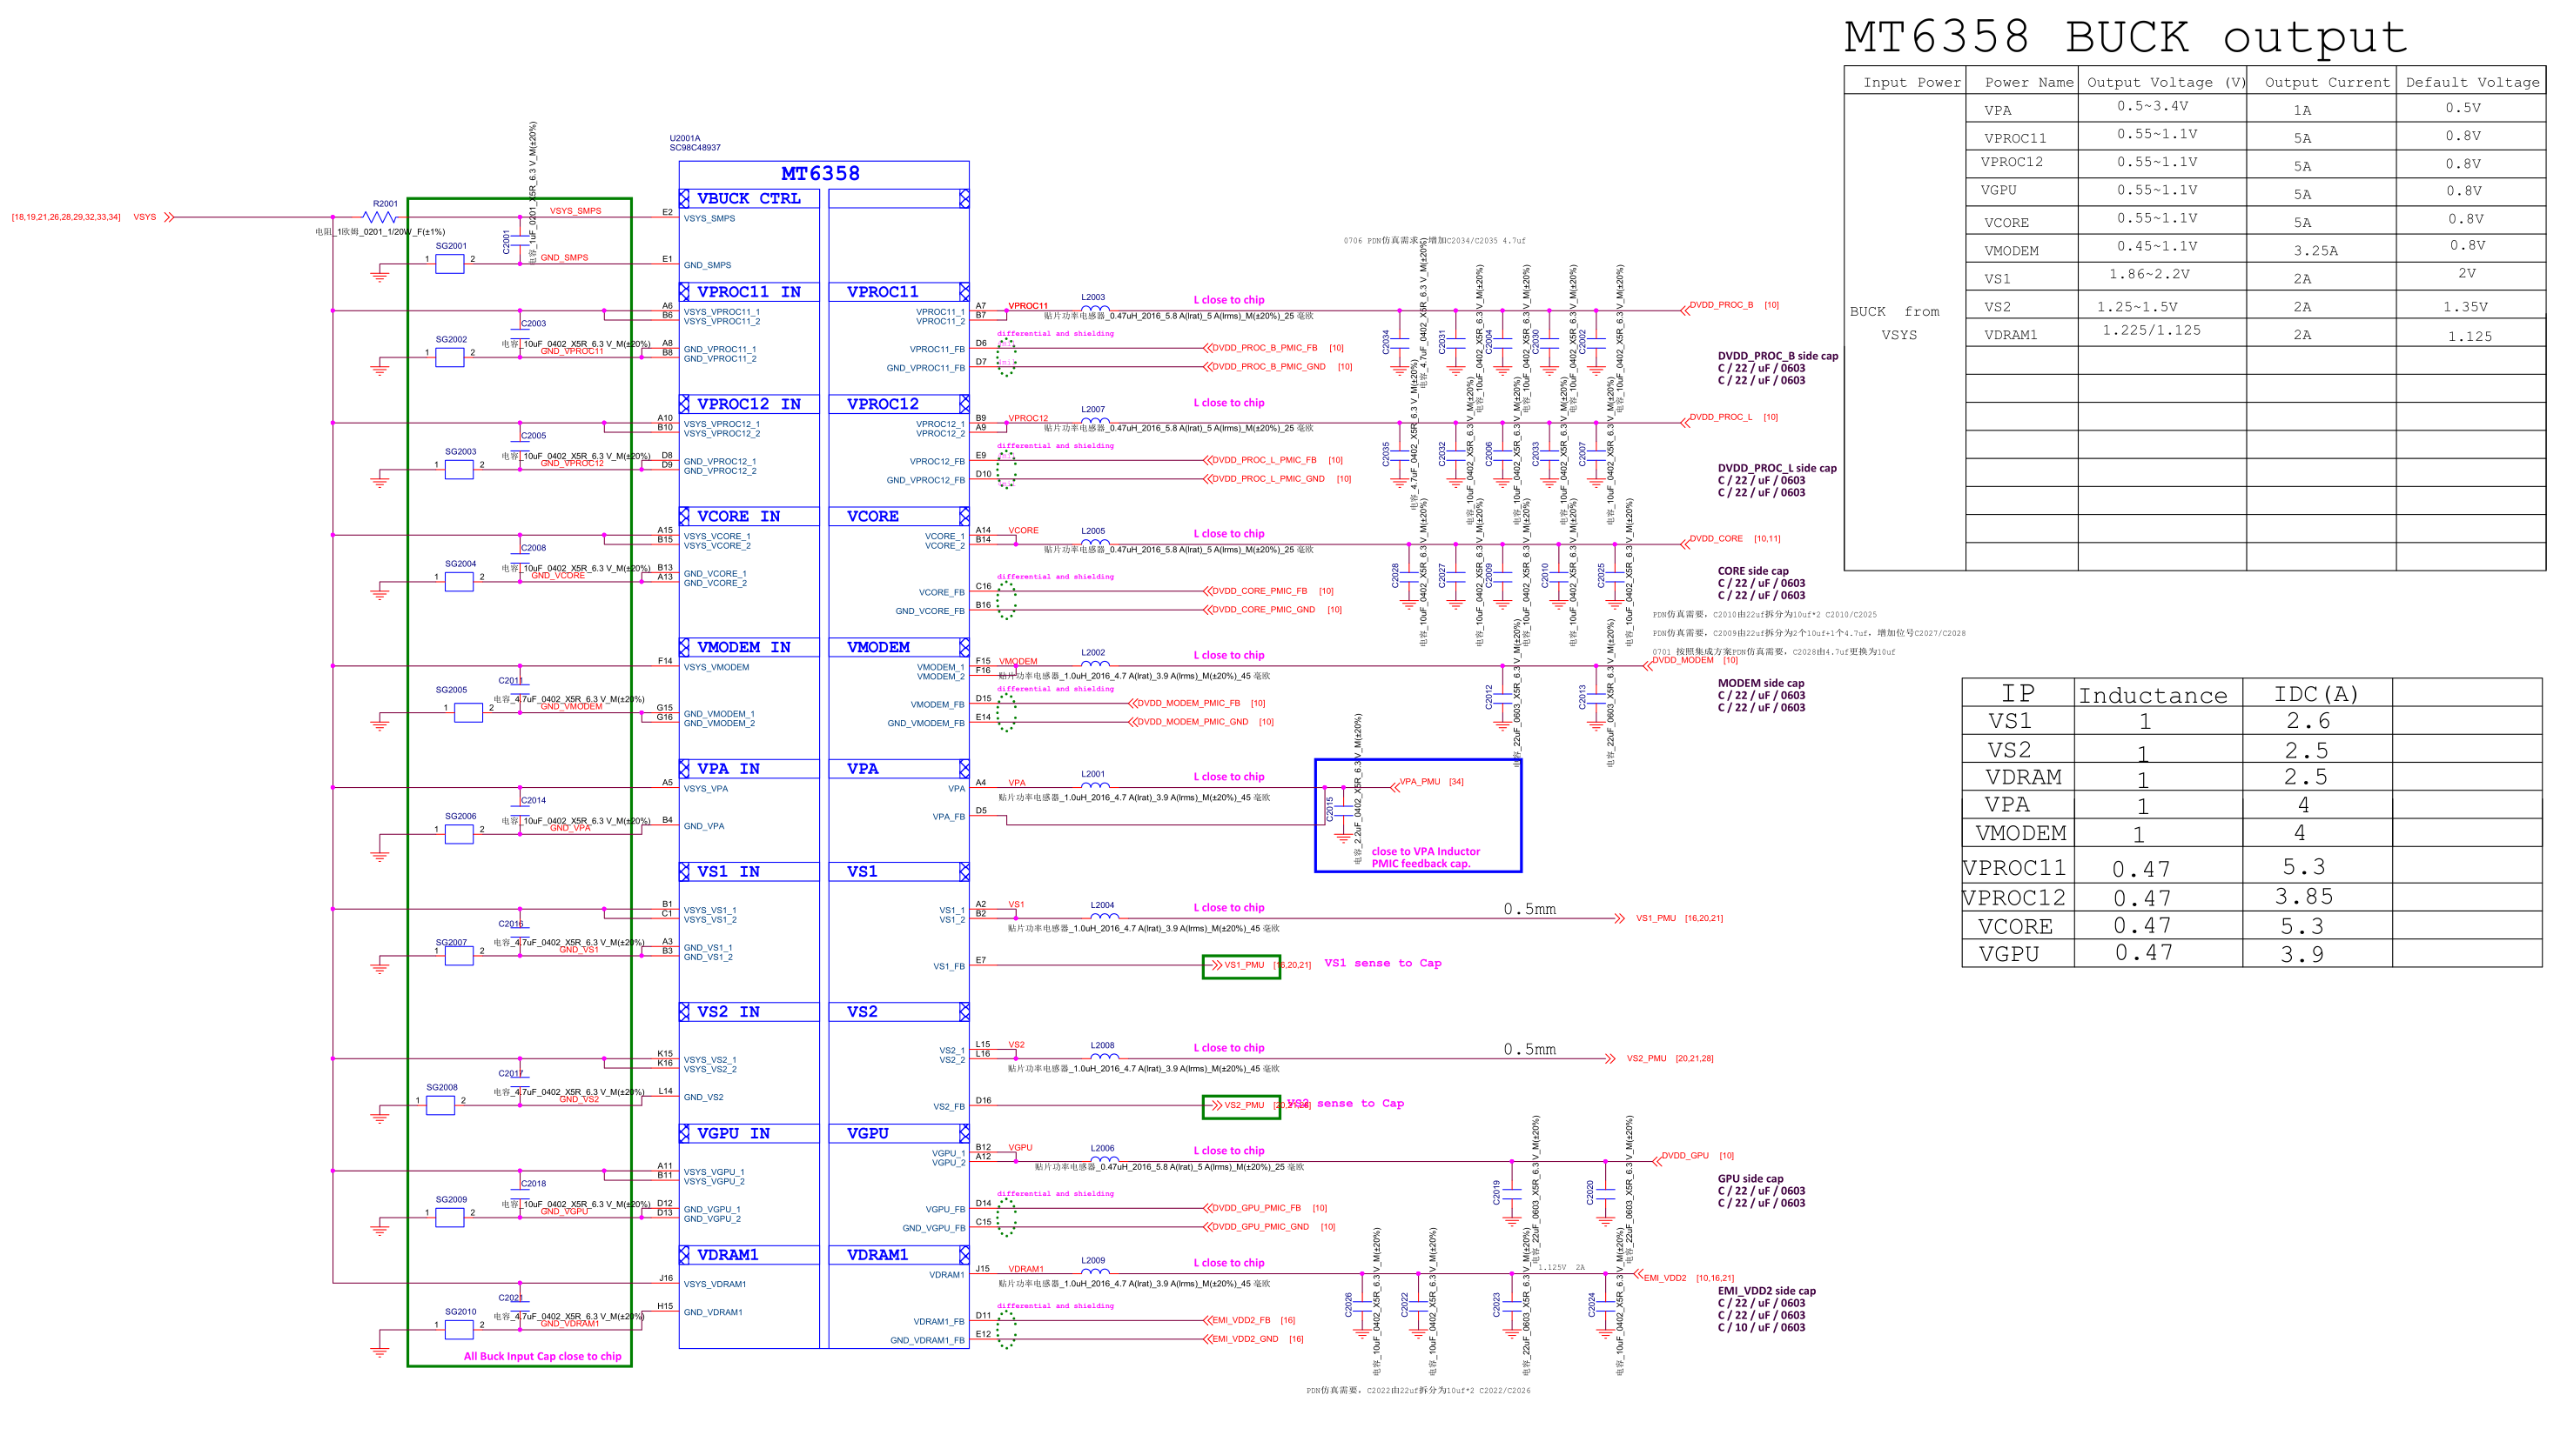

**21_POWER_MT6358_LDO**

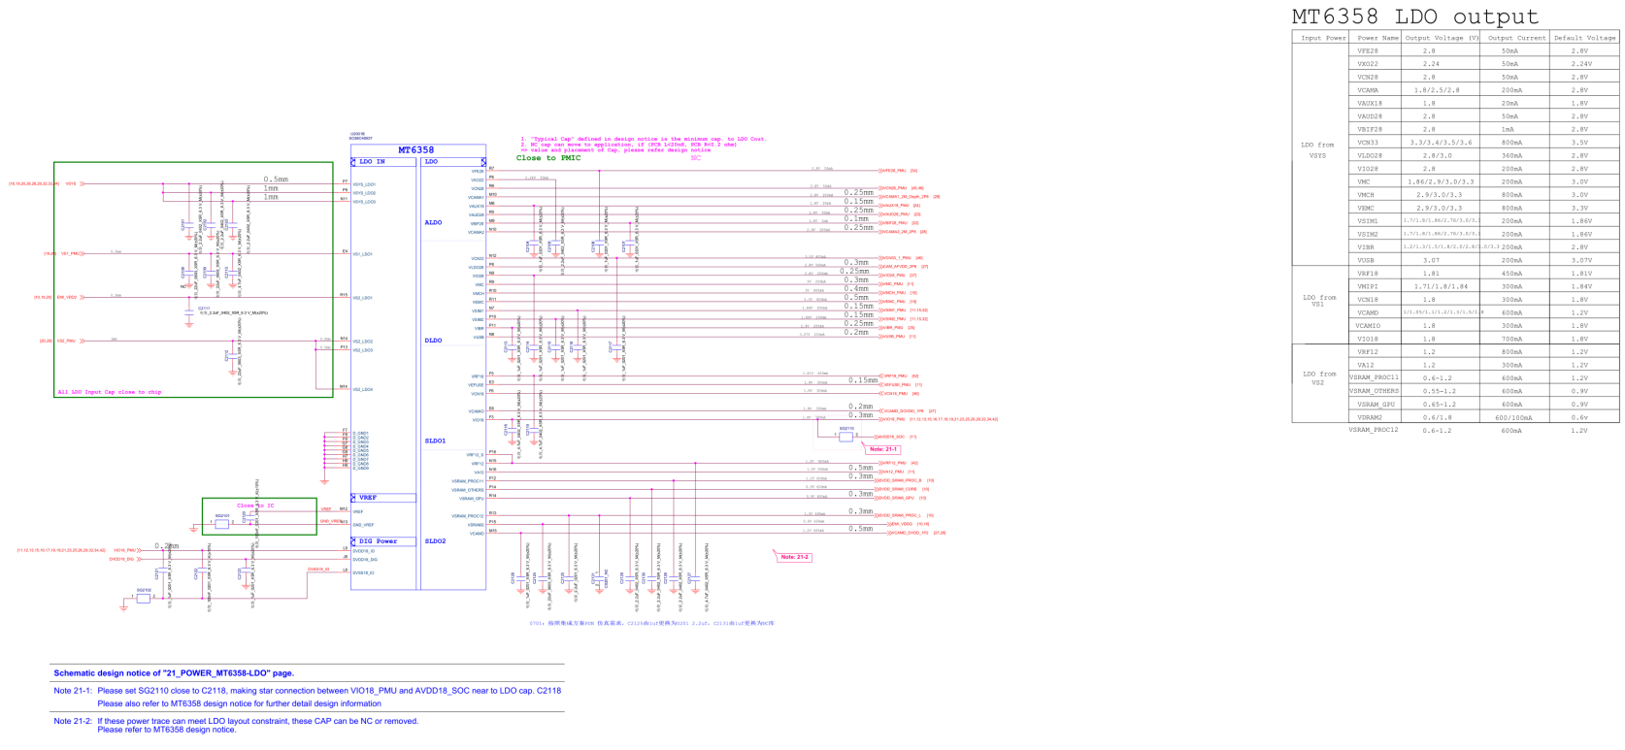

**22_POWER_MT6358_IF**

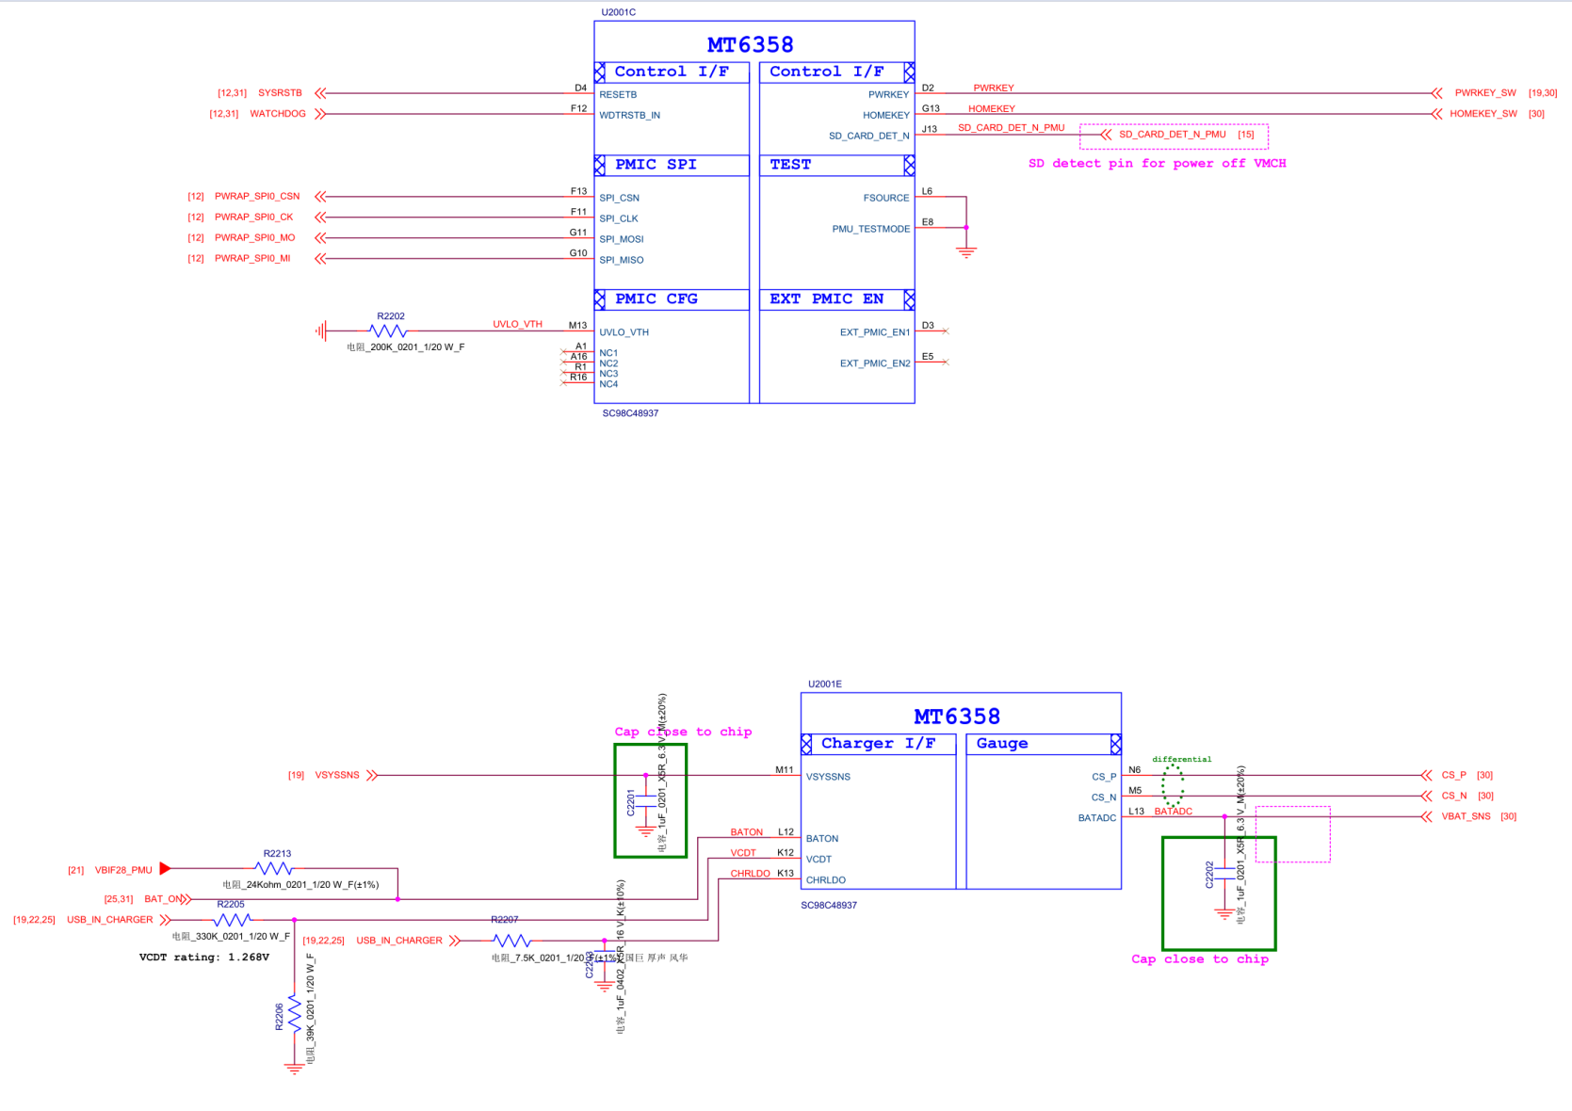

**23_POWER_MT6358_Audio**

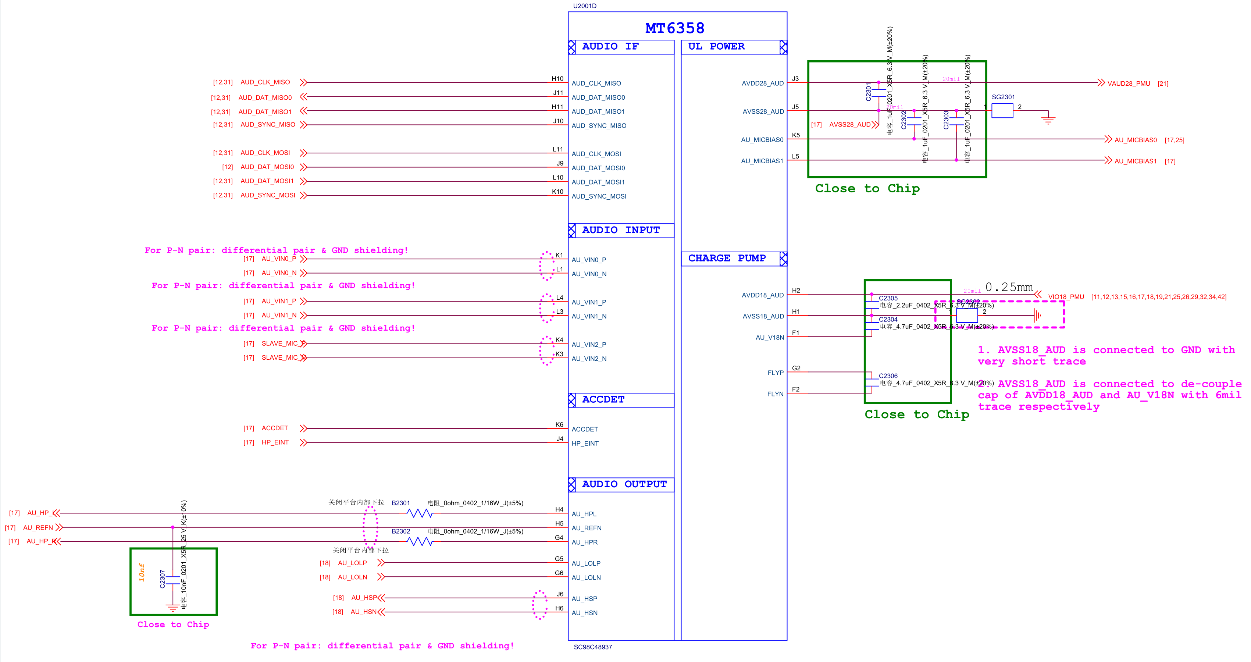

**24_POWER_MT6358_Clock**

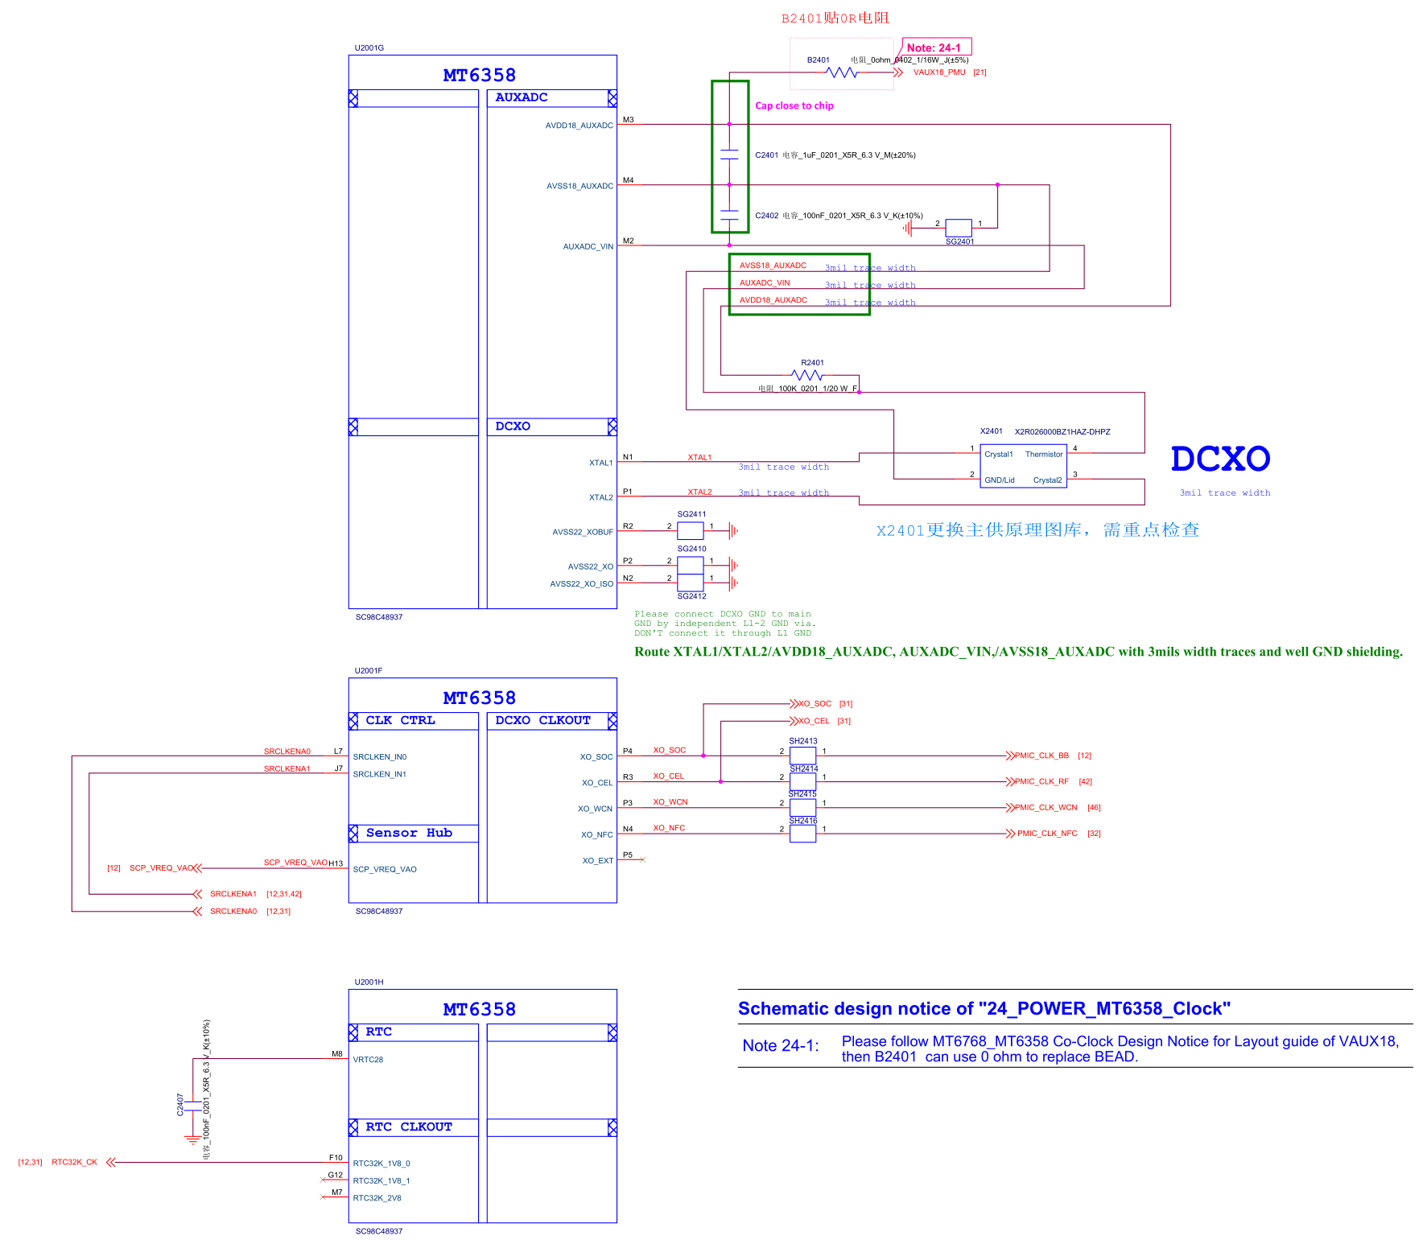

**25_LINK_OVP**

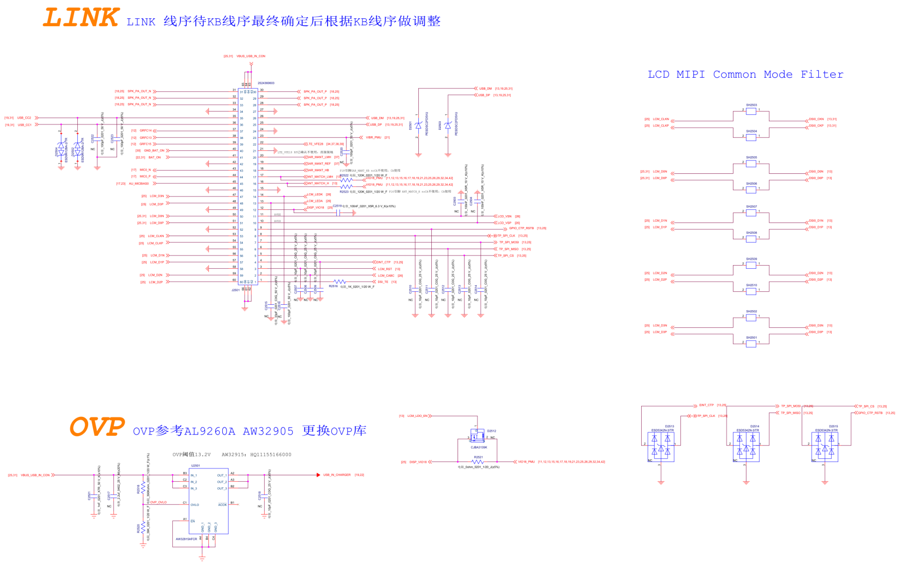

**26_LCD_BL_BIAS_Finger**

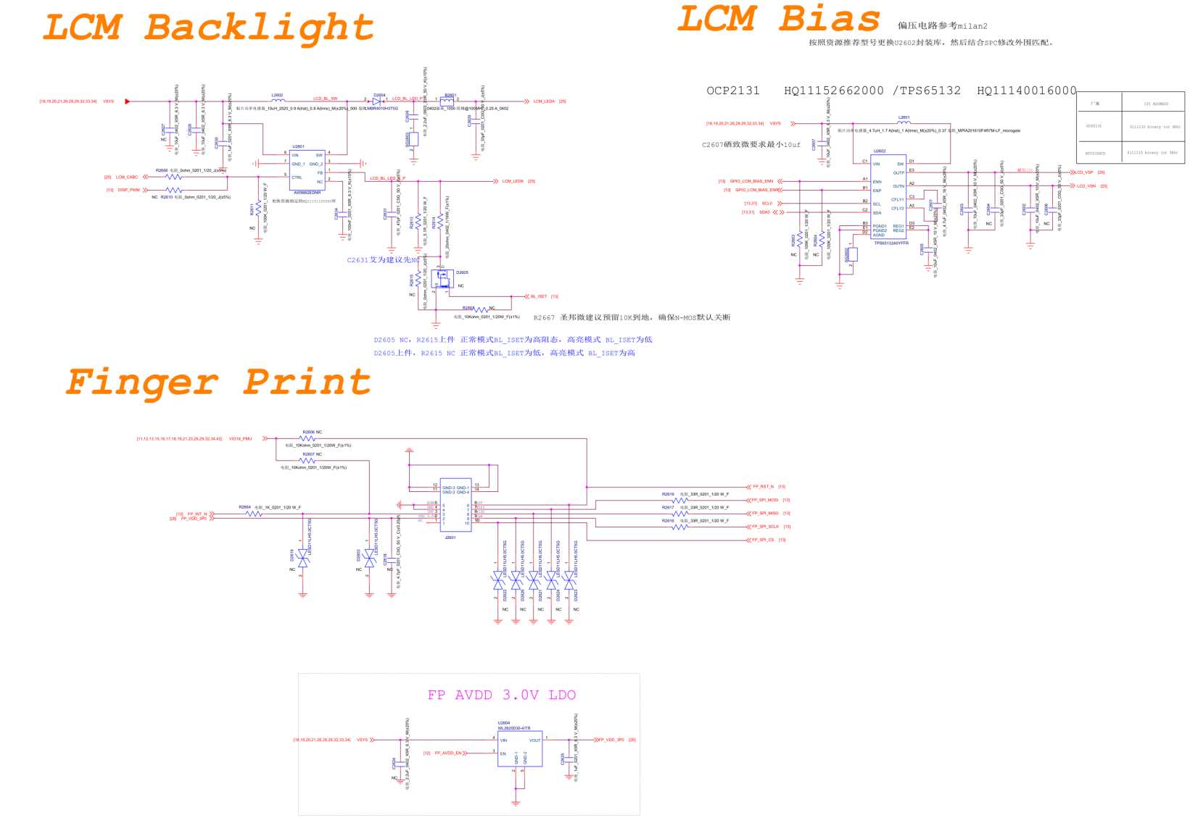

**27_Camera**

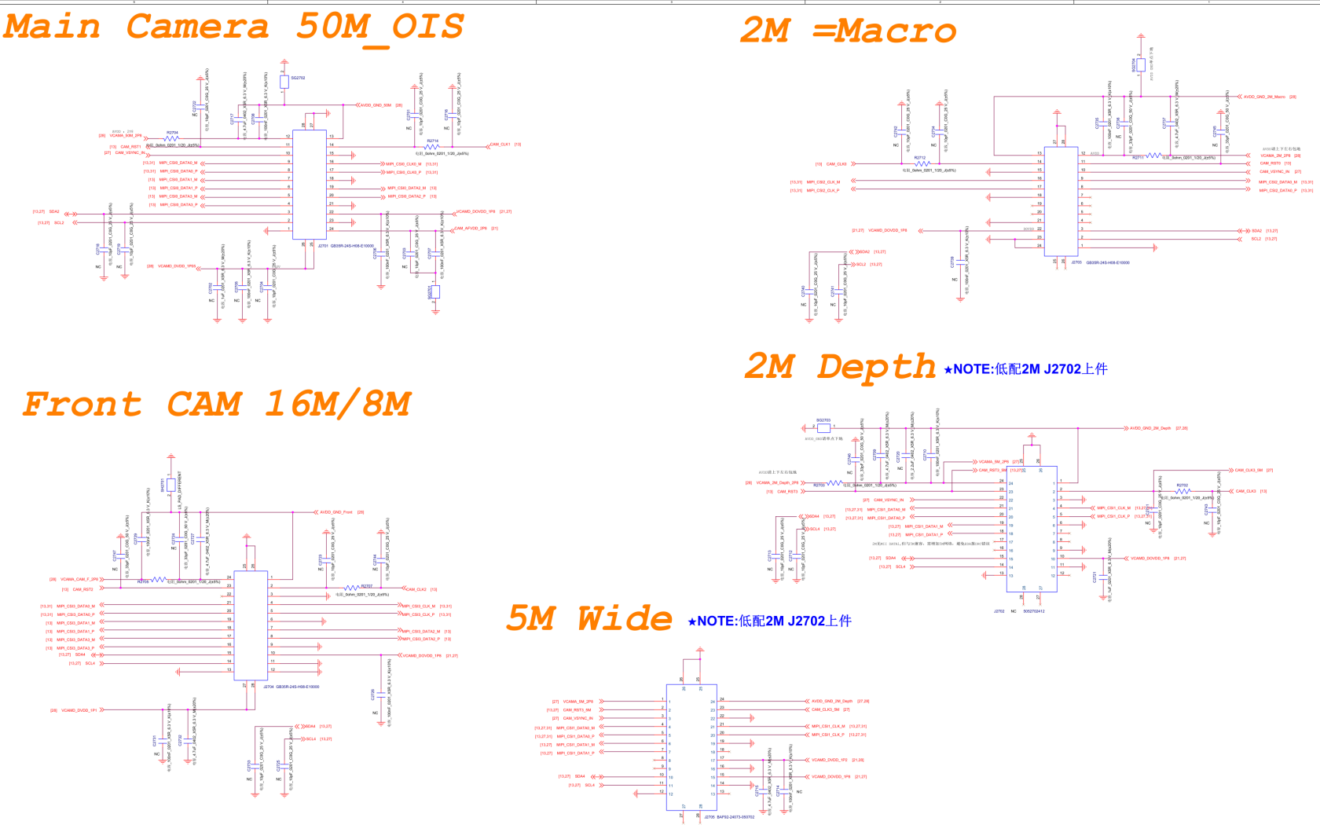

**28_Camera_Flash_Powers_LDO**

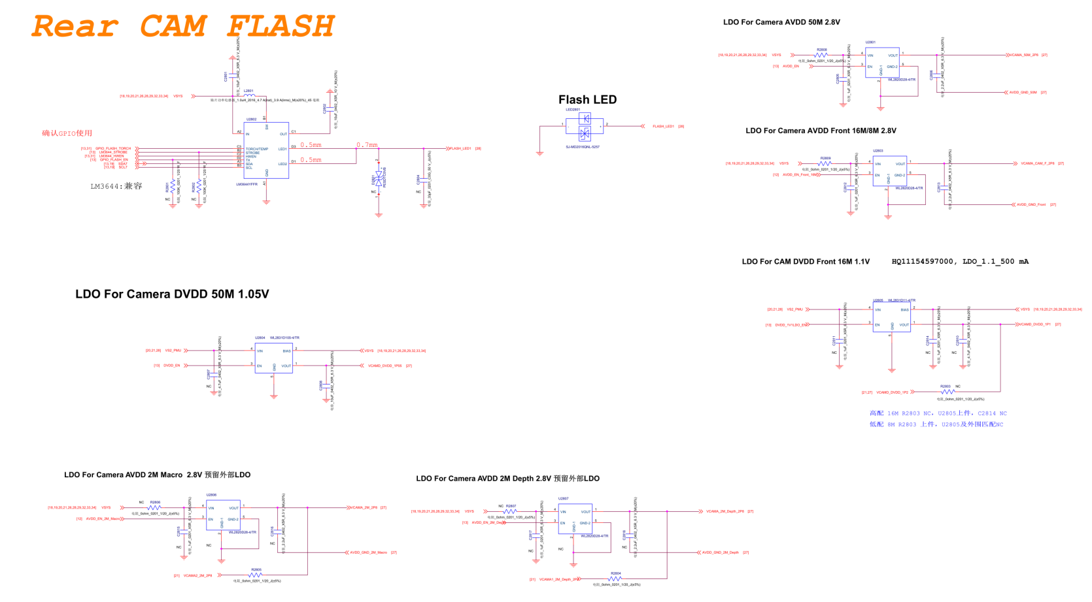

**29_Sensors**

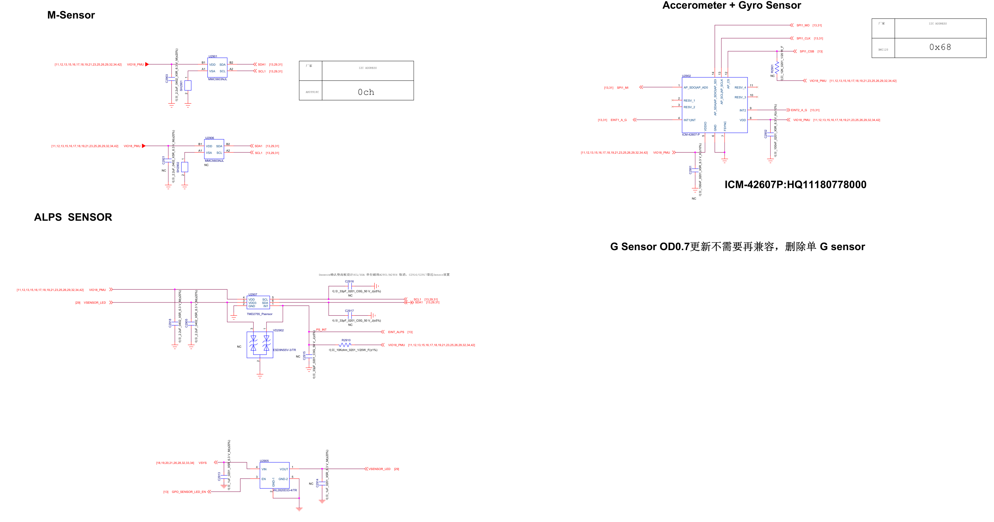

**30_BAT_Key**

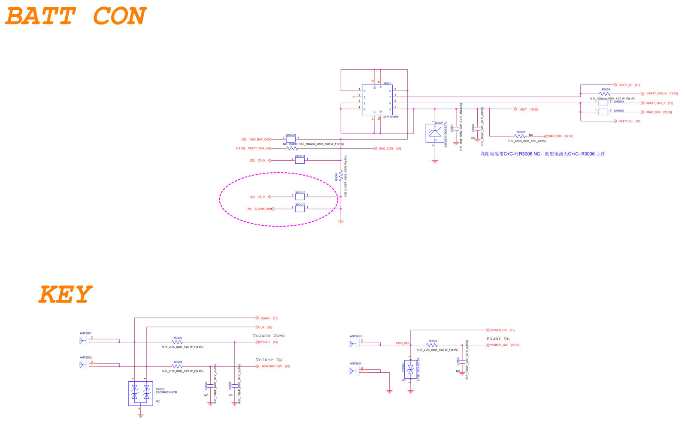

**31_Testpoint_Debug**

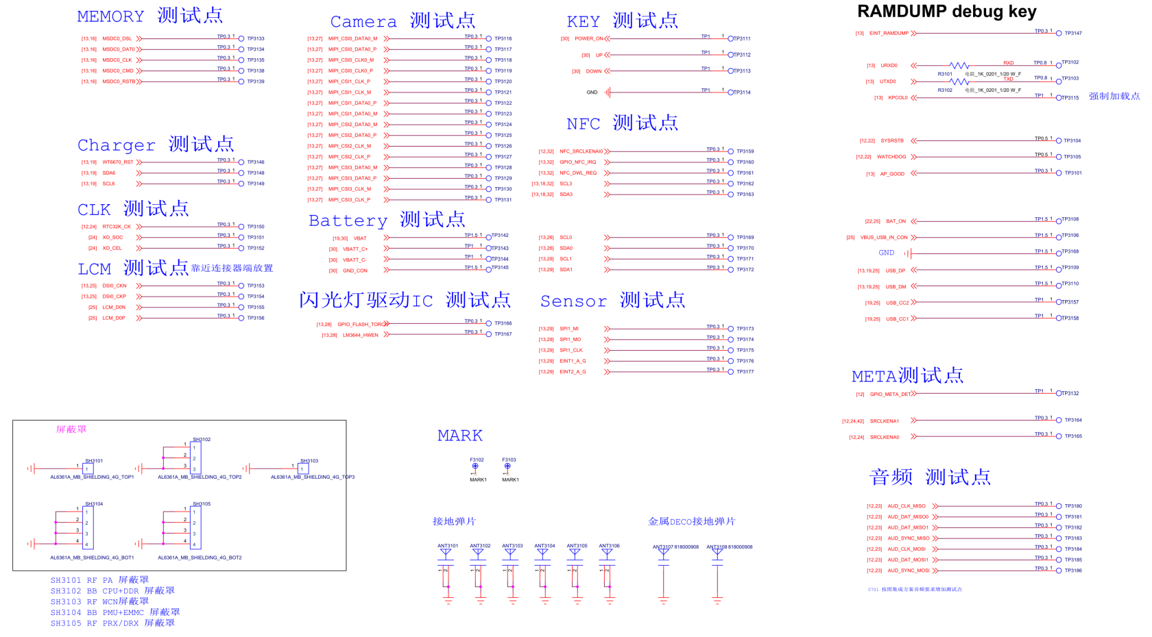

**32_NFC**

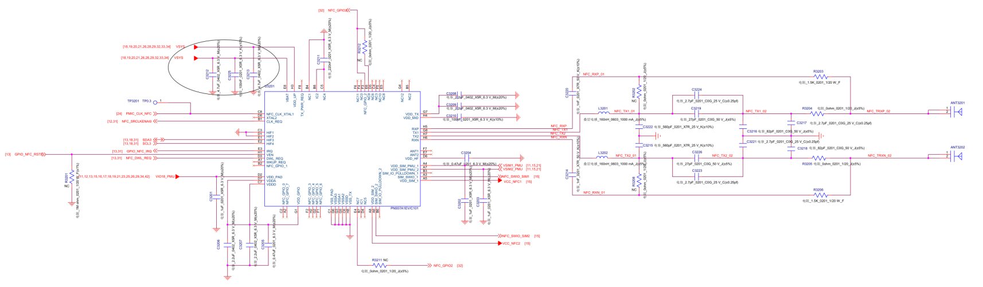

**QRD8953_2-4-2**

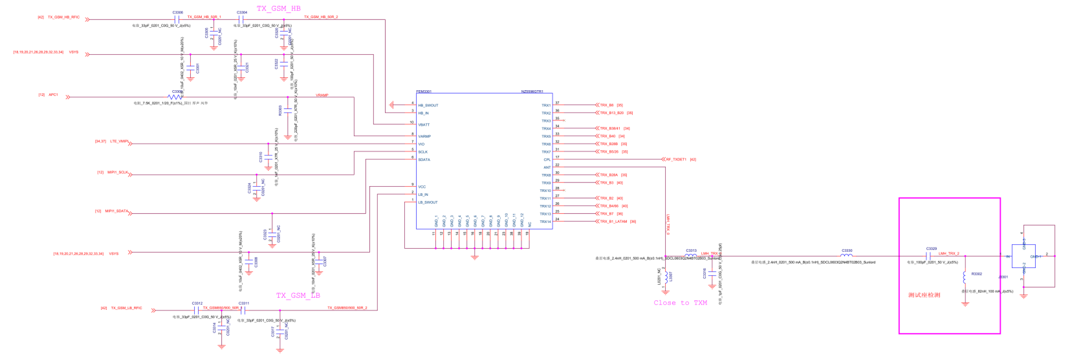

**B38/41**

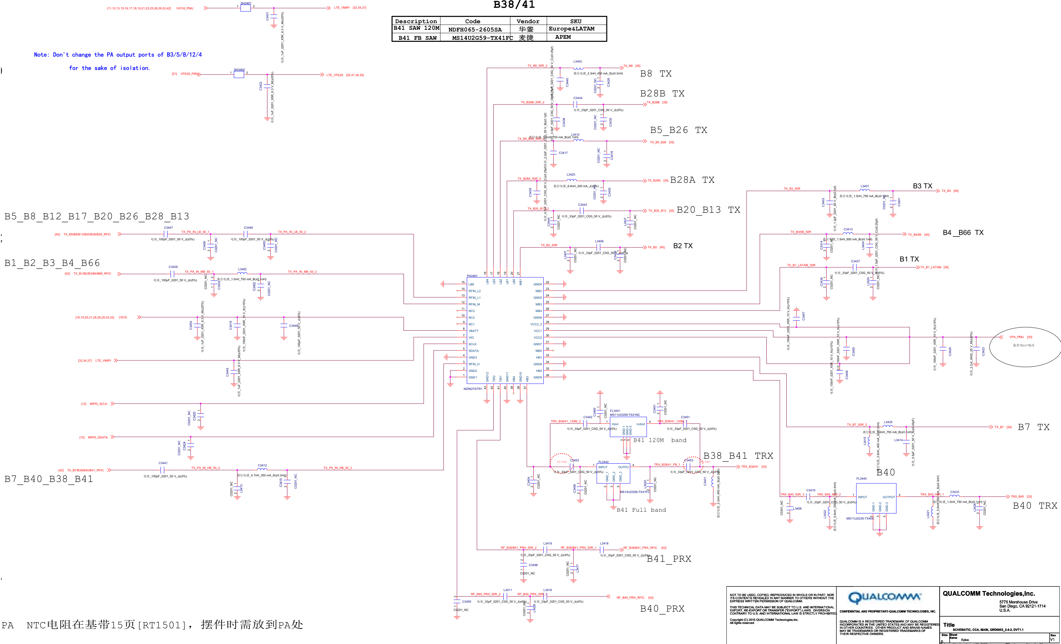

**DPX**

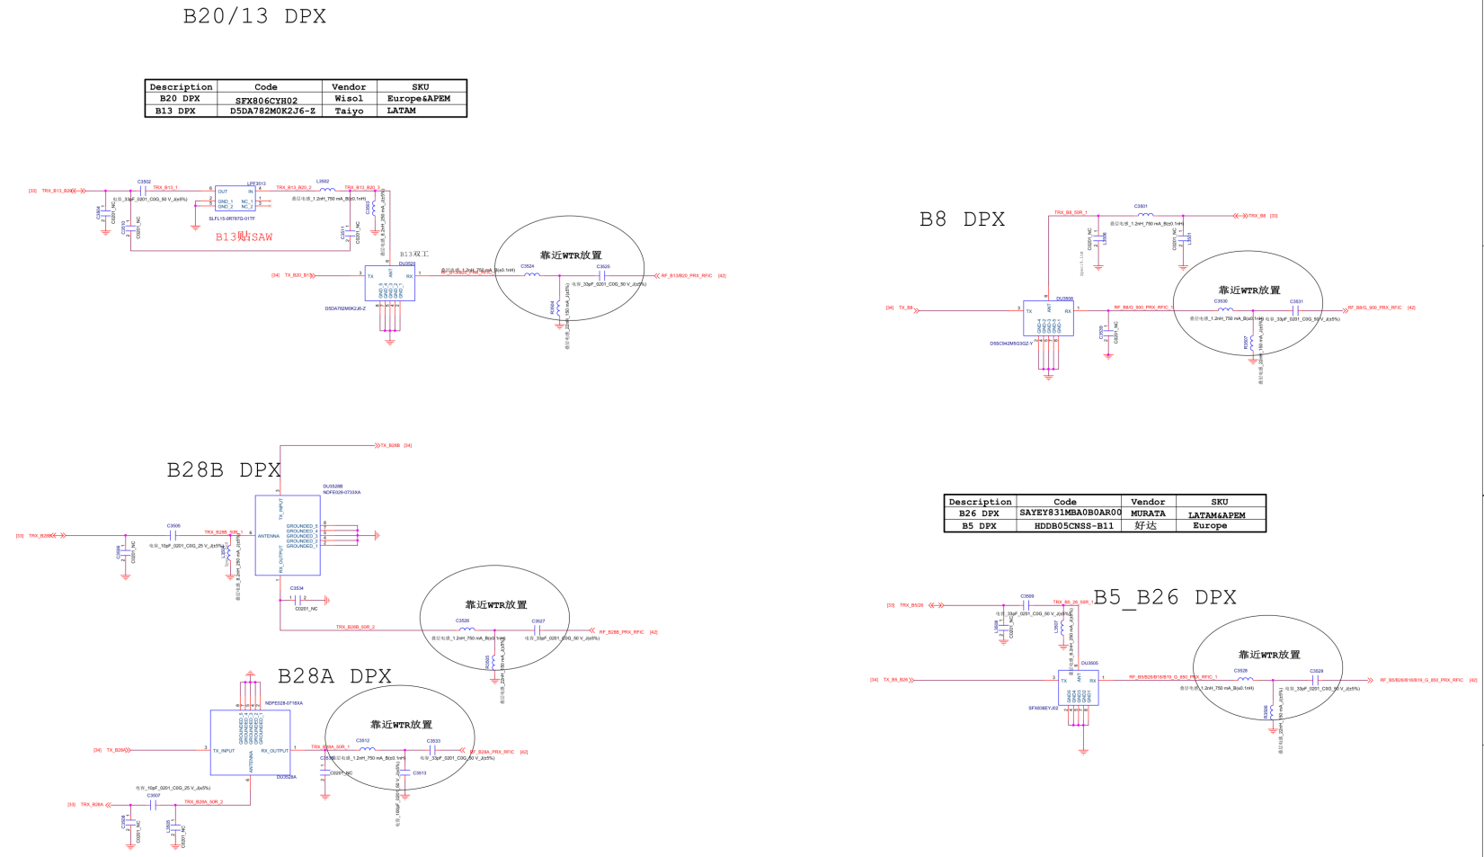

**DPX2**

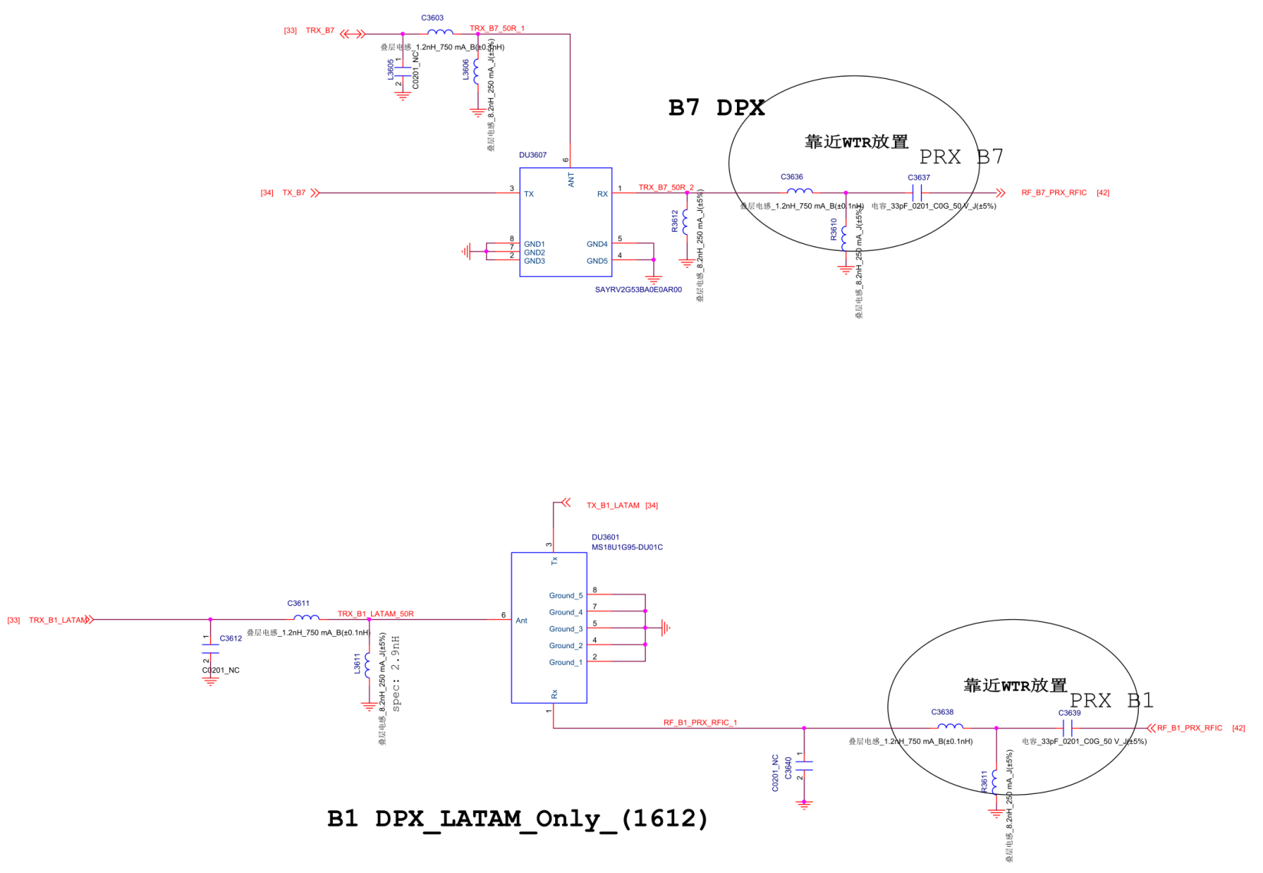

**SAR_SENSOR**

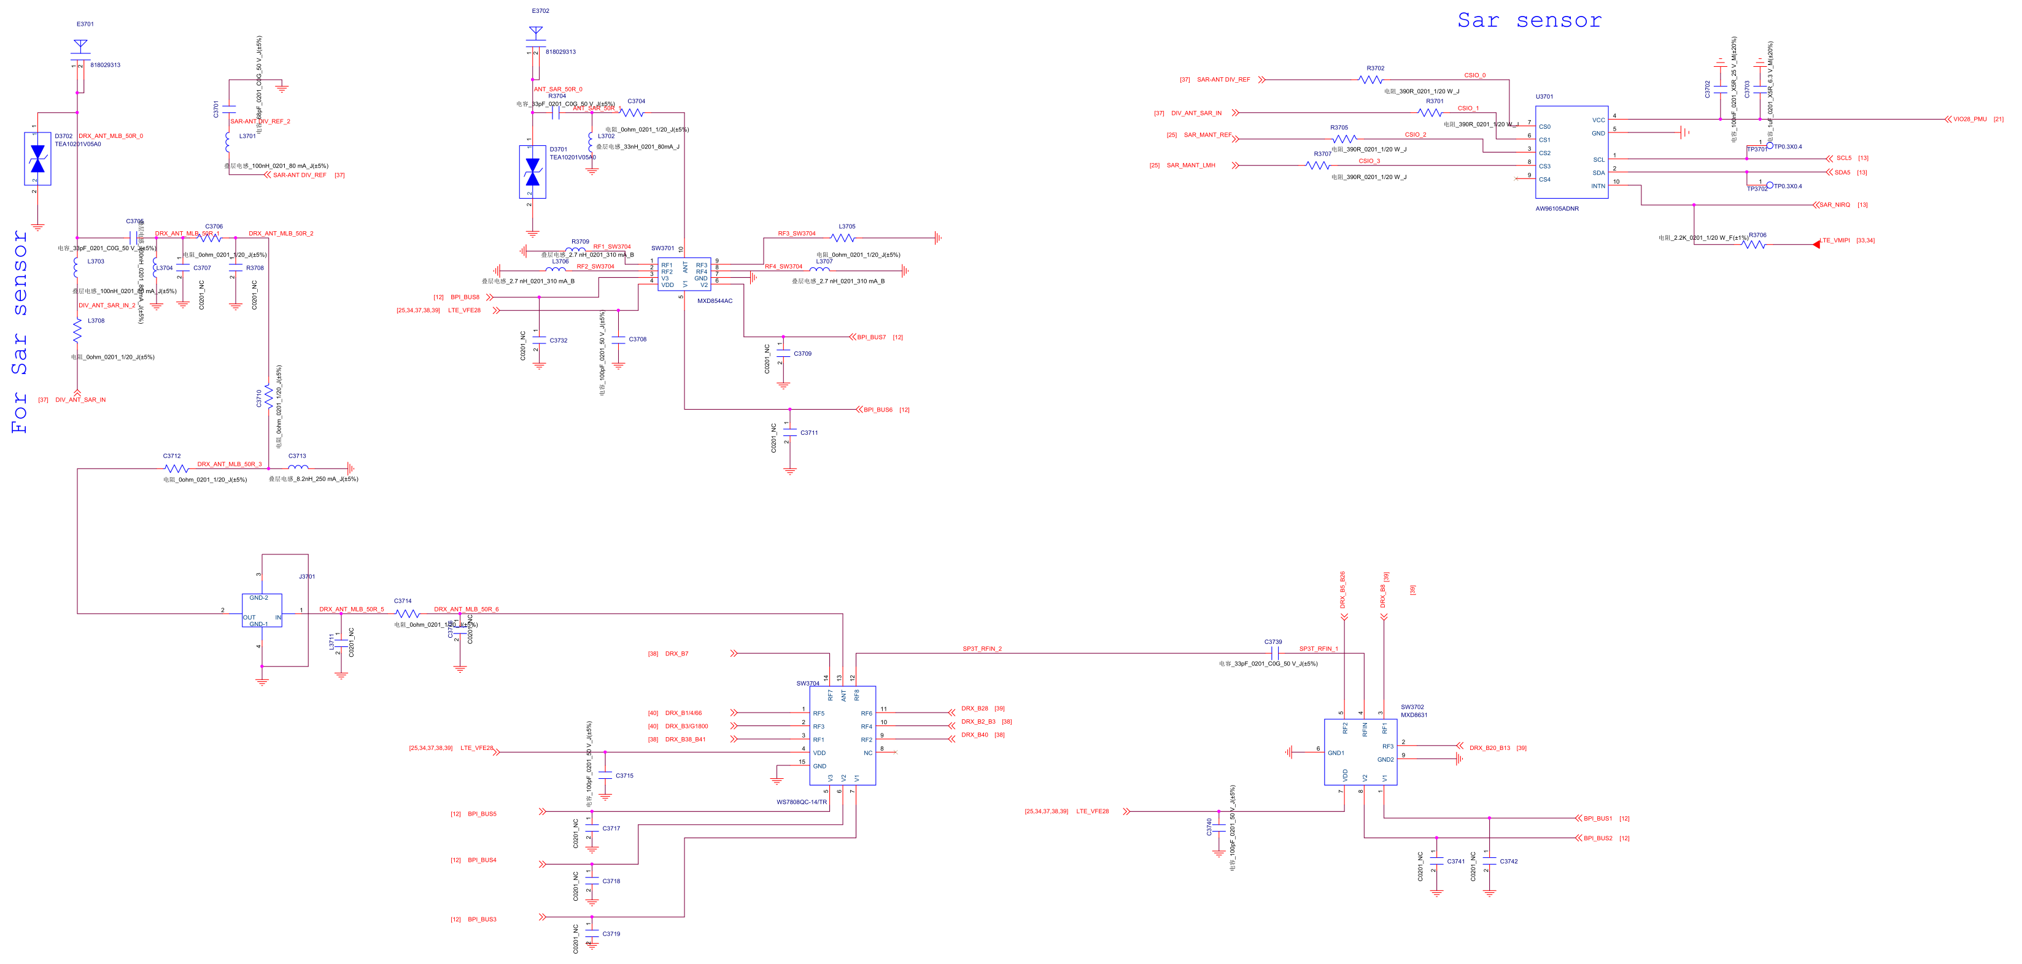

**B38_41_2**

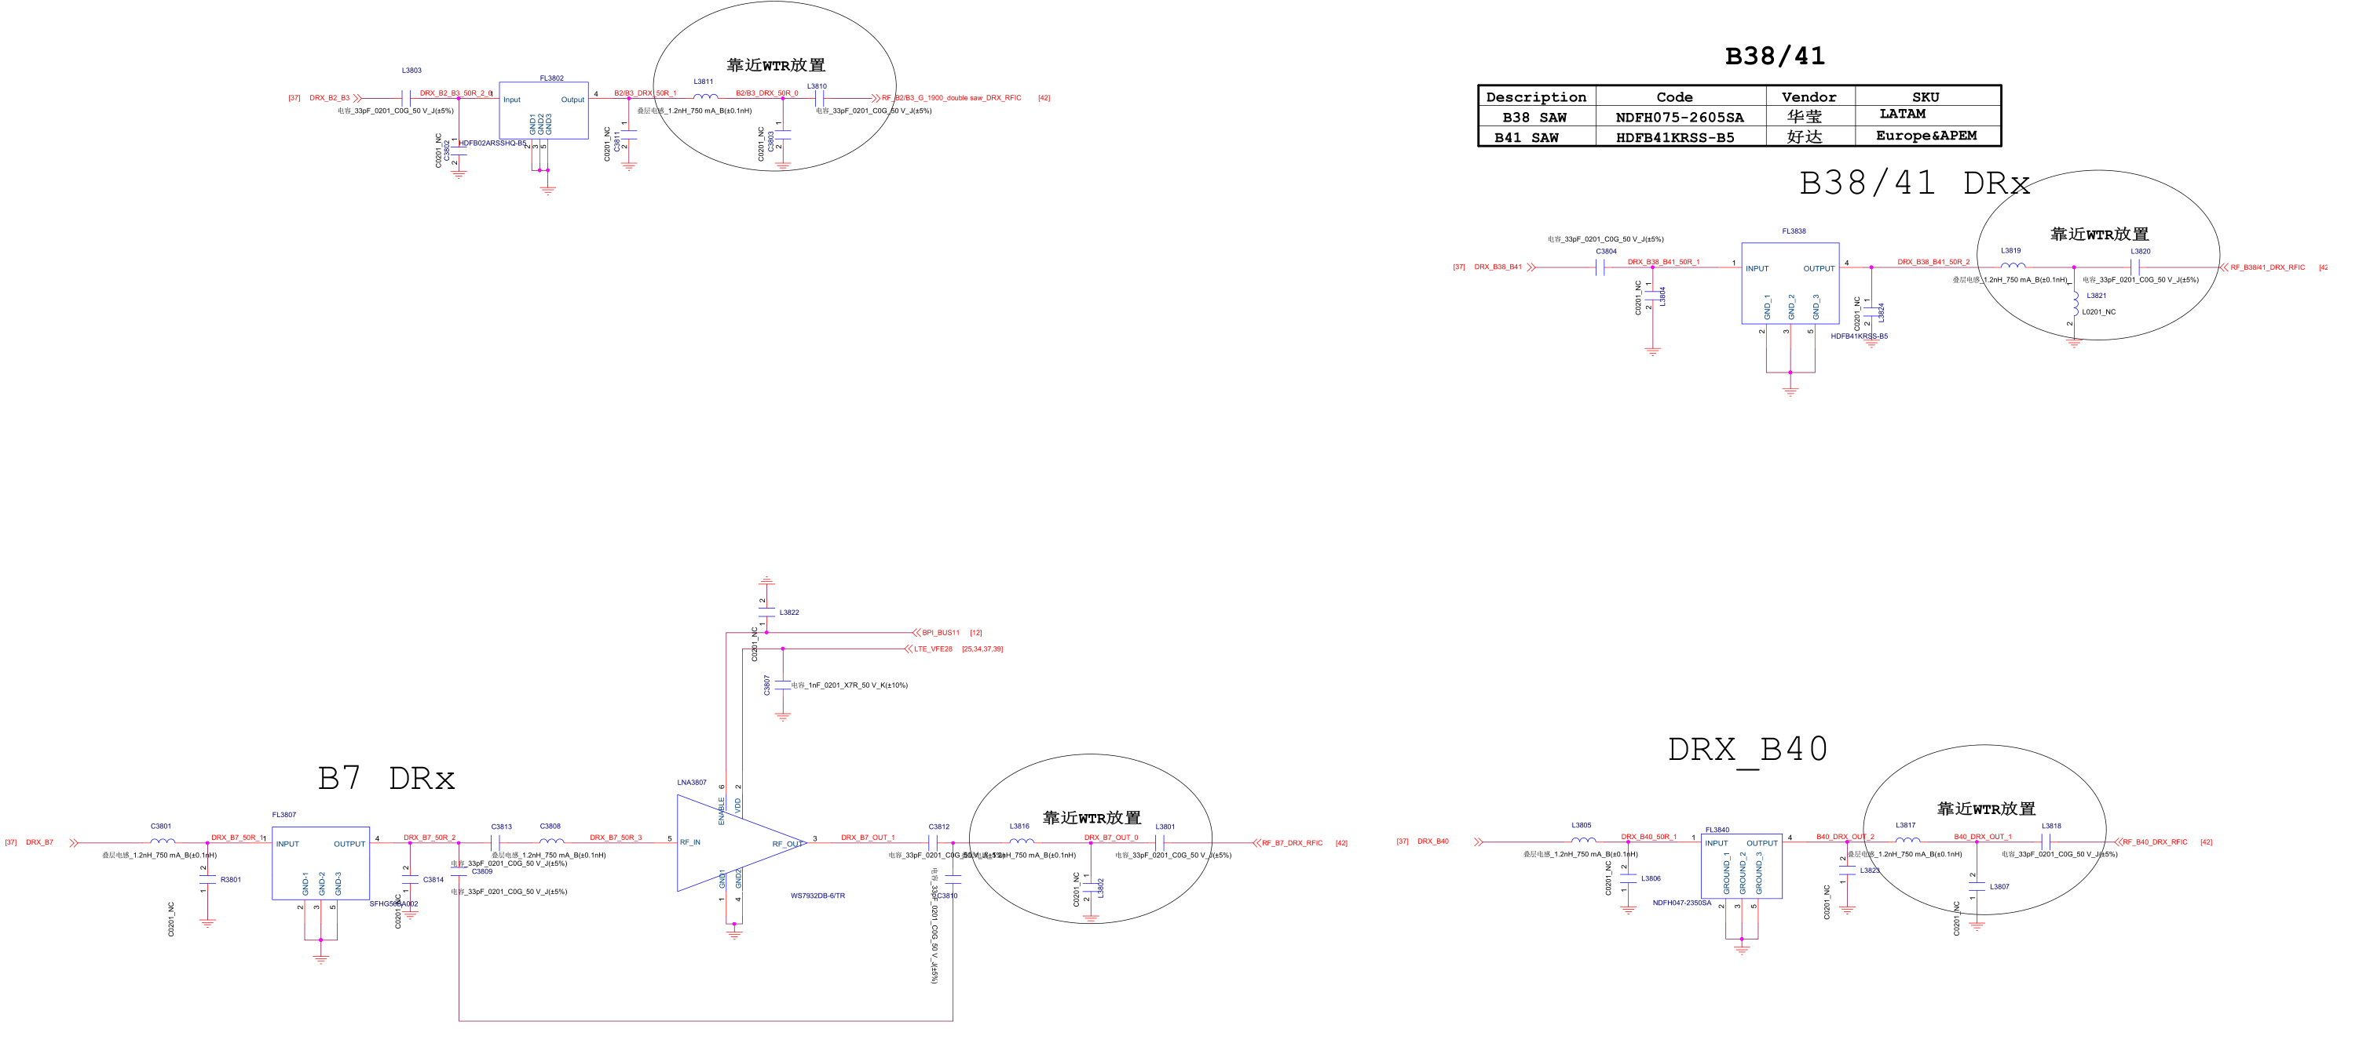

**DRX**

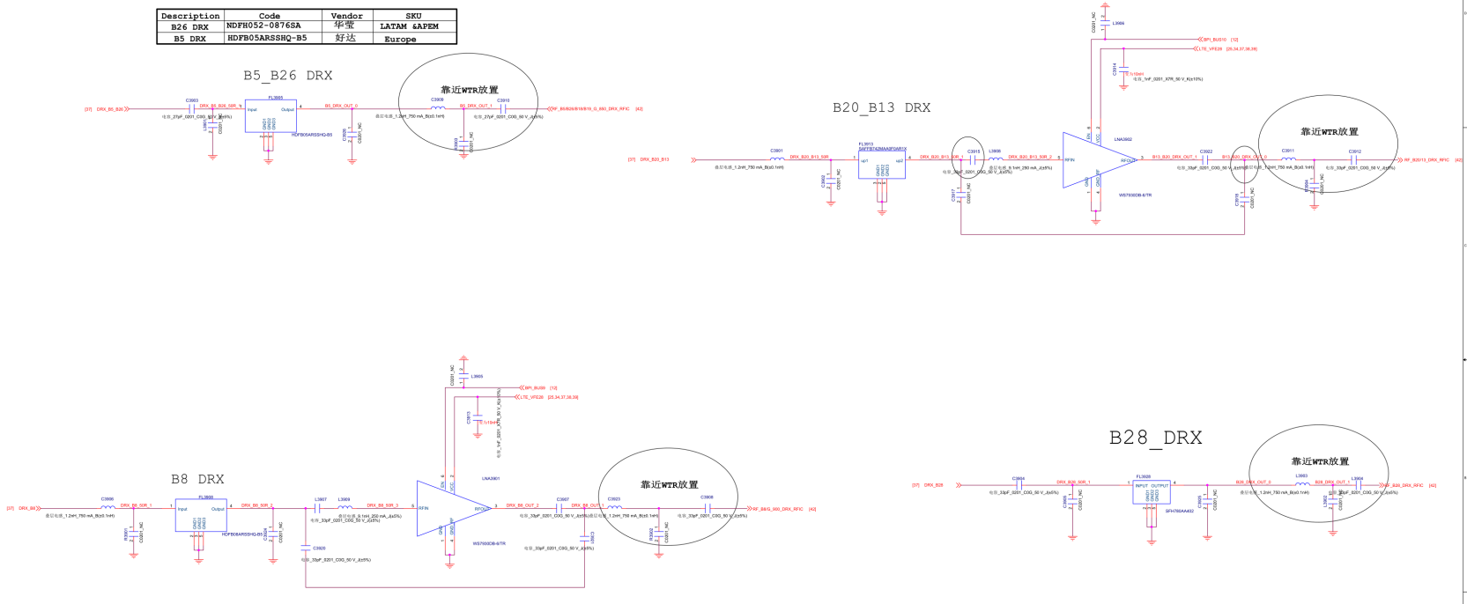

**B2  
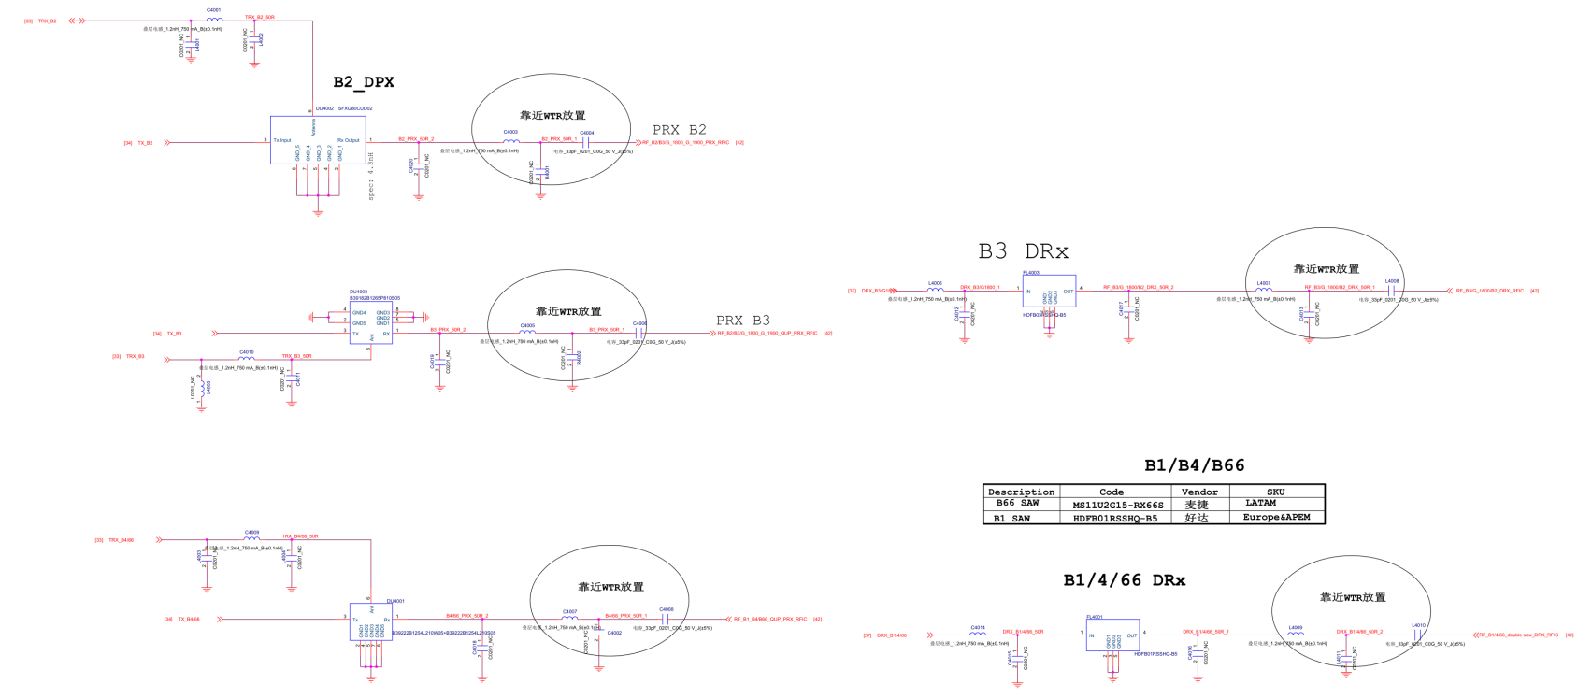**

**31_RF_MT6177_Pin_Out**

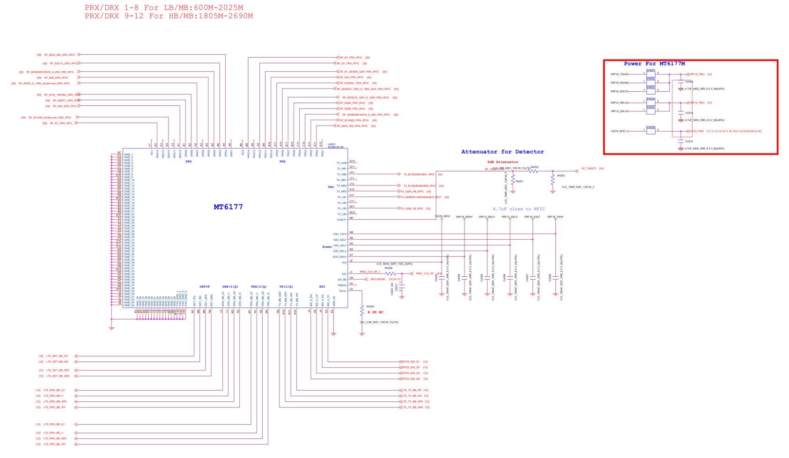

**WIFI 2.4G_BT_5G_GPS**

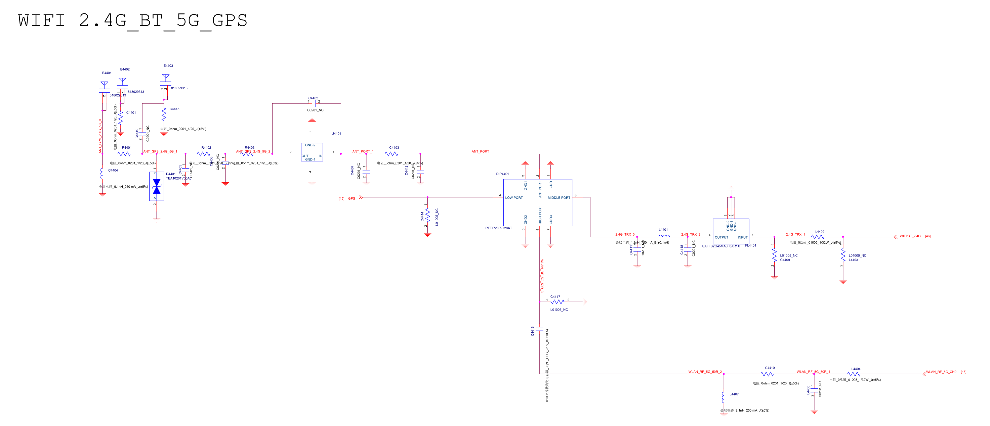

**GPS**

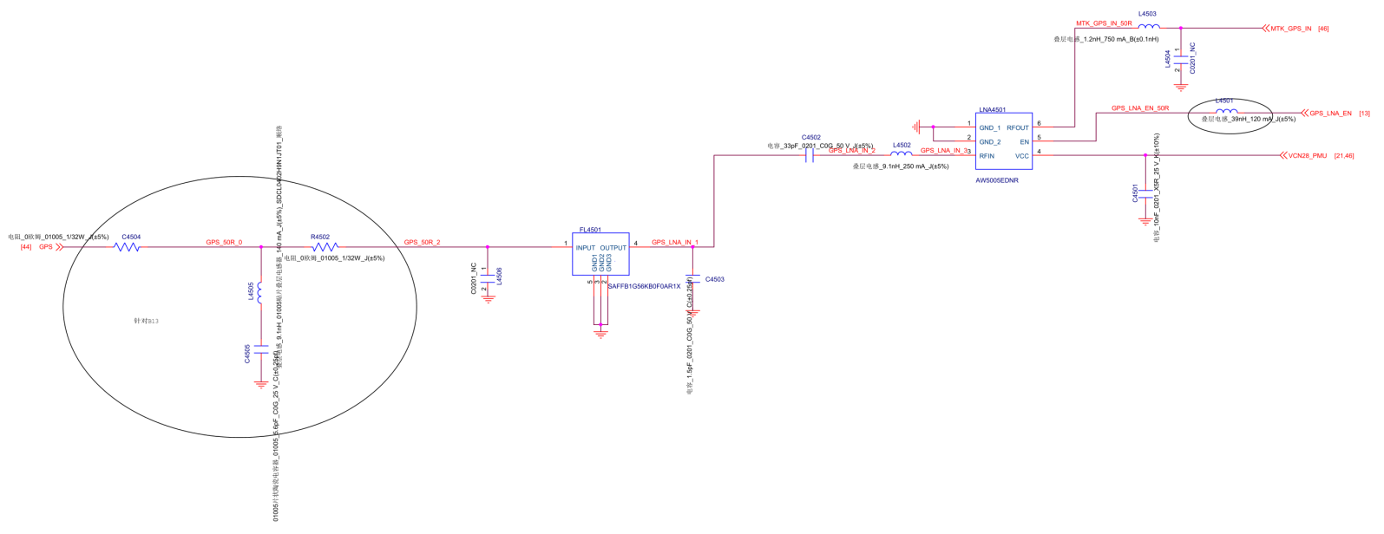

**36_RF_WCN_MT6631**

